IP MANAGEMENT · IP61019
Mid-Semester Notes
Simple explanations of the three examination units

Three units, nothing else
1. Definitions, Concepts and Context · 2. Intellectual Capital and Knowledge Economy · 3. IP Commercialization
Every sub-topic you listed is covered, in your order. Nothing outside the three units has been added.
Written in plain language. Short sentences. Each idea is defined, then explained, then given one example. The diagrams carry the structure — if you can redraw a diagram, you can rebuild the answer around it.

Contents

If this list is blank, click on it and press F9 (or right-click → Update Field).

Unit 1 — Definitions, Concepts and Context

1.1 Introduction to Intellectual Property Management
Until now you have studied what an IP right is and how to get it. IP management asks a different question. The right already exists — so what do we do with it? Is it worth the money we spend on it? Who should own it? Should we sell it, licence it, or use it ourselves?
Definition
IP management is the planned use of an organisation's intellectual property to create value. It brings together three things: technology, law and business. If any one is missing, the IP earns nothing.

Management in general means using resources in a planned way to reach a goal. In class the goals were listed as: increasing efficiency, cost-benefit optimisation, resource optimisation, reducing errors, increasing shareholder value, improving quality, and balancing the interests of different people. Each of these appears again in IP. Reducing errors becomes not missing a filing deadline. Balancing interests becomes settling the claims of the inventor, the employer, the sponsor and the public.

Administration and management are not the same
This is the most important distinction in the unit.
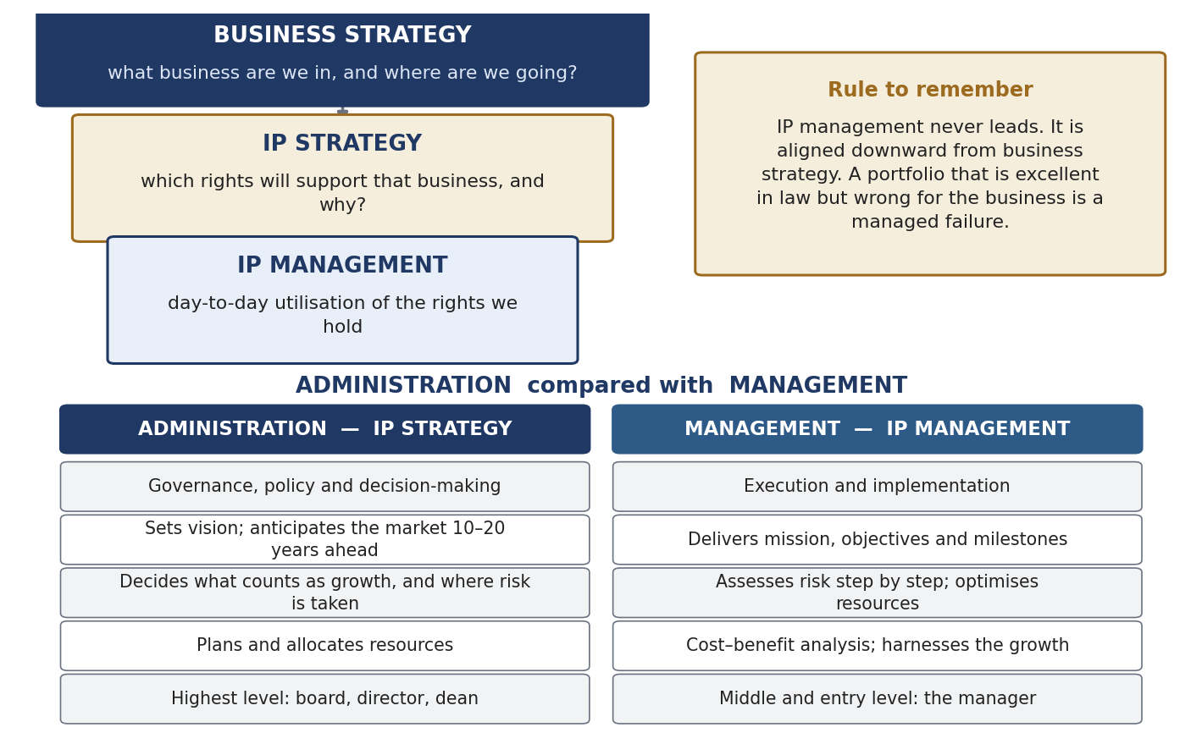
Figure 1.1 Business strategy sits on top. IP strategy comes from it. IP management carries it out.
- Administration = the top level. It makes policy, takes decisions and thinks 10 to 20 years ahead. In IP, this is called IP strategy. Example: the board decides the company will move into automotive sensors.
- Management = the level below. It implements, executes, meets targets and manages risk step by step. In IP, this is IP management. Example: the IP department decides which inventions to file, in which countries, and at what cost.
Remember the order: business strategy → IP strategy → IP management. IP management never leads. It always follows the business. A portfolio that is legally perfect but wrong for the business is a failure.
One warning. Do not think drafting and prosecution are unimportant “back-end” work. One word in a claim decides what the patent covers for 20 years. One word in a contract decides who owns the next invention. Strategy appears wherever a single choice changes a future outcome.

Why IP management became a separate subject
IP rights are very old, but IP management is new. It appeared in the 1980s and 1990s. The reason is a set of changes in the United States called the pro-patent era.
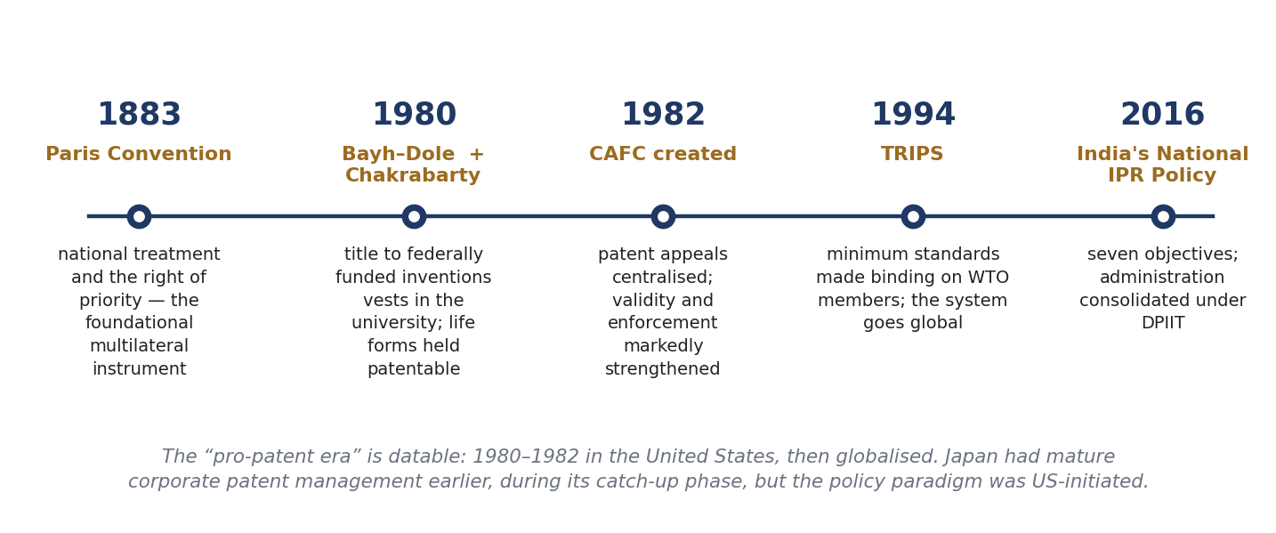
Figure 1.2 The dates that made IP management necessary.
- 1883 — Paris Convention. The first big international agreement on industrial property. It gave two things: national treatment (foreigners treated like locals) and the right of priority.
- 1980 — Bayh–Dole Act. In the USA, universities and small businesses could now own inventions made with government funding. Suddenly there was an owner who could licence, so companies had someone to deal with.
- 1980 — Diamond v. Chakrabarty, 447 U.S. 303. The US Supreme Court held (5–4) that a living, genetically engineered organism can be patented. Patentable subject matter widened enormously.
- 1982 — CAFC created. All patent appeals in the USA went to one court. Patents became much stronger and much harder to invalidate.
- 1994 — TRIPS. Minimum IP standards became binding on all WTO members. The system went global.
- 2016 — India's National IPR Policy. Seven objectives; IP administration brought under DPIIT.
Once patents became strong, valuable and global, portfolios grew very large. A large stock of valuable assets needs managing. That is when the job was created. (You only go to a wealth manager after you have wealth.)
Correction to a common class claim
It is often said that “Japan pioneered IP management and then it shifted to the USA”. The accurate version: Japanese companies did build very strong patent cultures during their catch-up period, but the pro-patent era as a policy change started in the USA in 1980–1982 and then spread. Also, do not give a single year for the birth of IP management. Say “the 1980s and 1990s”.

What an IP manager actually does
Two lists are useful. Sullivan (1998) listed the key responsibilities: generating IP, managing the portfolio, valuing it, converting intellectual assets into competitive assets, and taking strategic decisions. The class used a simpler four-stage cycle:
- Recognise and categorise the IP — is it protectable, and under which law?
- Brand it — give it identity and communicable value.
- Grow and defend it — build the portfolio, monitor, enforce, maintain.
- Value it — because every decision above needs a number.

1.2 Basic Definitions and Concepts
Learn this section exactly. Everything later is built on it.

The four terms and how they fit inside each other
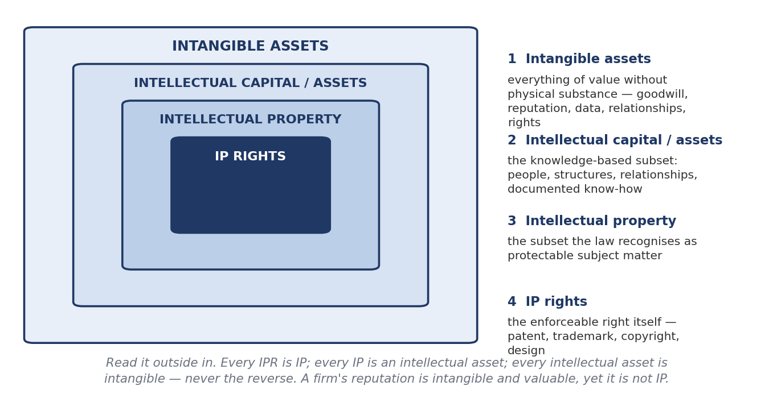
Figure 1.3 Read from outside to inside.
Term | Meaning
Intangible asset | Anything valuable with no physical form. Widest term. Includes goodwill, reputation, customer relationships, data — things no IP law covers
Intellectual capital / intellectual assets | The knowledge-based part of that: people, systems, relationships, documented know-how
Intellectual property | The part of it that the law recognises as protectable
IP right (IPR) | The actual enforceable right — patent, trademark, copyright, design
Table 1.1 Every IPR is IP. Every IP is an intellectual asset. Every intellectual asset is intangible. The reverse is never true.
Two points that are always asked
1. IP is a subset of intangible property. Never the other way round.
2. IP has its own dedicated law — Patents Act, Trade Marks Act, Copyright Act, Designs Act. Other intangibles have no dedicated law. They are protected only through general law: contract, confidentiality, employment terms, passing off. That is the real difference between the two branches.

Also note how much contract law is involved. When you file a patent you disclose the invention and the State gives you a right — that exchange is like a contract. Every licence, assignment, NOC and confidentiality undertaking is a contract. Weak contract law means weak IP management.
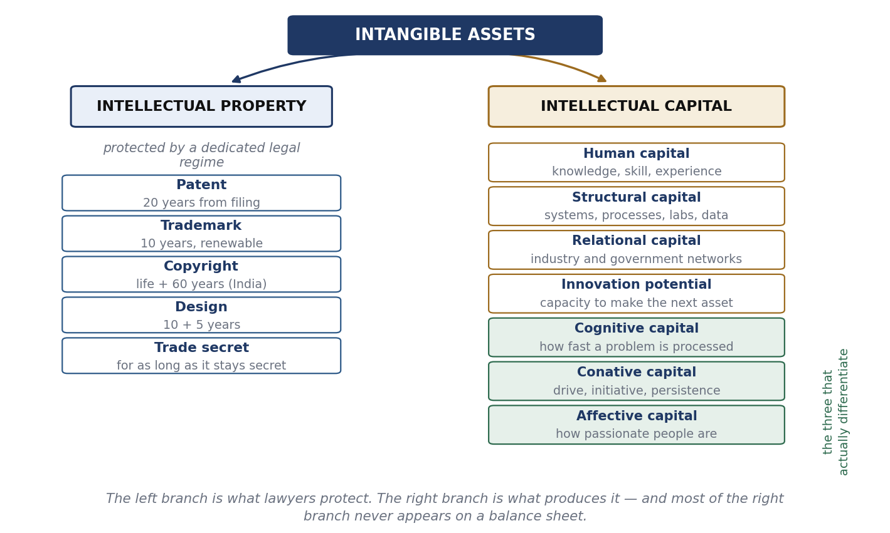
Figure 1.4 Classification of intangible assets. The left branch is what lawyers protect; the right branch is what produces it.
Why most intellectual capital is invisible in the accounts
Under IAS 38 (and Ind AS 38 in India), internally generated goodwill, brands and customer lists cannot be shown as assets, and all research spending must be written off as expense. So a company that spends ten years building a great portfolio shows almost nothing on its balance sheet. The gap between a company's market value and its book value is where intellectual capital is hiding. This gap is the reason the whole measurement subject in section 1.3 exists.

From data to an intellectual product
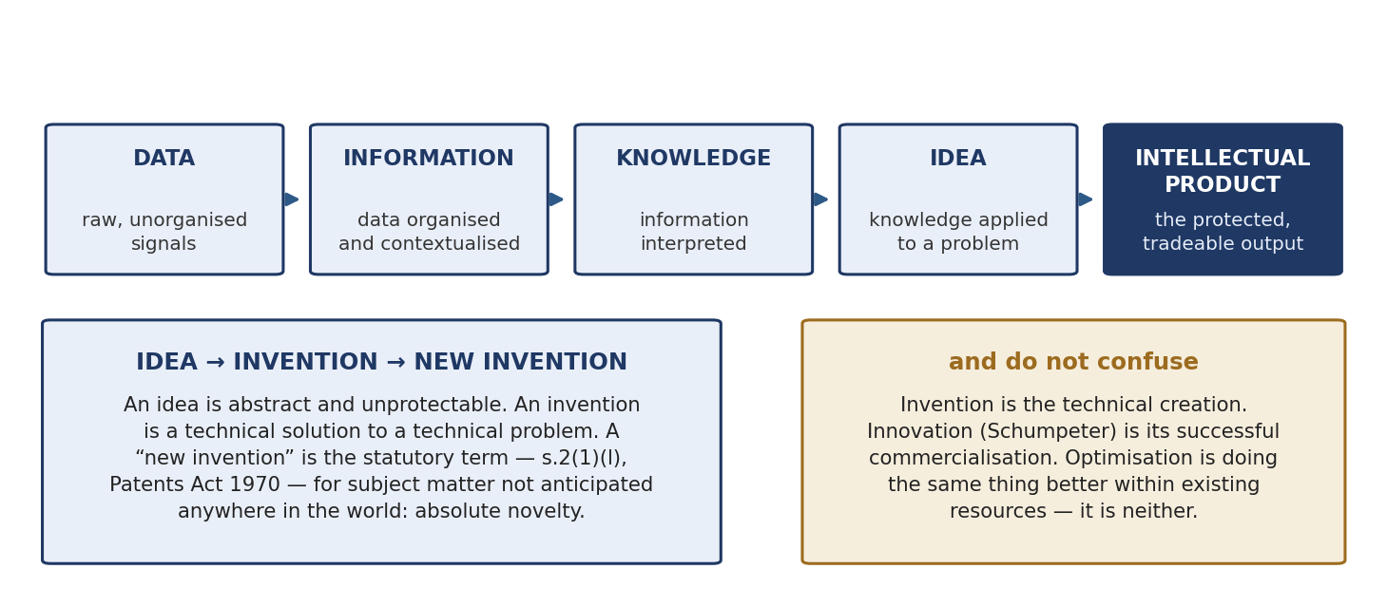
Figure 1.5 The knowledge chain and the three distinctions built on it.
Data are raw signals. Organise them and you get information. Interpret information and you get knowledge. Apply knowledge to a problem and you get an idea. Protect and develop the idea and you get an intellectual product.
- Invention vs innovation. Invention = the technical creation. Innovation = its successful commercialisation. An invention that nobody sells is not an innovation.
- Optimisation. Doing the same work better with the same resources. Class example: an operator realised after 30 years that a plate on a tobacco machine could be turned the other way, cutting time and cost. That is optimisation — and it may still be patentable, because trial-and-error discoveries are not excluded.
- “New invention” is a statutory term. Section 2(1)(l) of the Patents Act 1970: an invention not anticipated by publication anywhere in the world, or used in India or elsewhere, before the date of filing with complete specification. This is absolute novelty. Compare s.2(1)(j) (invention) and s.2(1)(ja) (inventive step).

Why a patent is called a negative right
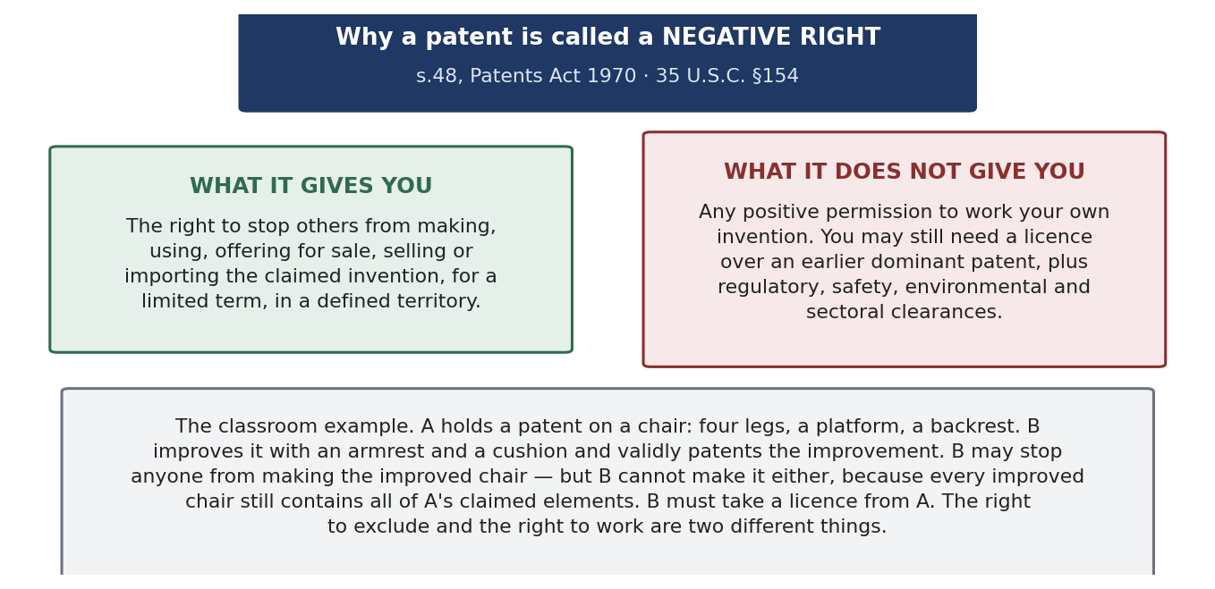
Figure 1.6 What the patent gives and what it does not give.
Section 48 of the Patents Act 1970 gives the patentee the right to stop others from making, using, selling, offering for sale or importing the invention. It does not give the patentee any right to work the invention. 35 U.S.C. §154 in the USA is worded the same way.
The chair example makes it clear. A has a patent on a chair: four legs, a platform, a backrest. B improves it by adding an armrest and a cushion, and gets a valid patent on the improvement. B can stop everyone from making the improved chair. But B cannot make it either, because every improved chair still contains all of A's parts. B must take a licence from A. So the right to stop others and the right to work are two different things.
Is this true only of patents? The usual argument is yes: an author can always use his own work and a trademark owner can always use his own mark, but a patentee may be blocked. The better answer notes that all exclusive rights are structurally rights to exclude. The real difference is one of degree. Technology is cumulative, so improvements always contain earlier inventions; expression can usually be created independently.

Value and price are different
Value is what the asset is worth in use. Price is what someone actually pays. In IP the gap between them is large, because there is usually no market and no comparable sale.
Within IP, trademark value moves the most. A trademark's value comes from goodwill and reputation, which can be destroyed by one event — Kingfisher Airlines, or Nestlé's Maggi recall in 2015. A patent's value comes from the technology and the claim, which does not disappear overnight; it falls slowly as the term runs out or as substitutes appear.

Treaty, convention, protocol, agreement, contract
- Treaty — a binding agreement between States under international law.
- Convention — in substance a treaty; the word is used for multilateral instruments made under an international organisation (Paris Convention).
- Protocol — an additional instrument attached to a parent treaty (Madrid Protocol).
- Agreement — the widest word; used internationally (TRIPS) and in private law.
- Contract — under s.2(h) of the Indian Contract Act 1872, an agreement enforceable by law. Section 10 gives the conditions: free consent, competent parties, lawful consideration and object, not expressly void. So every contract is an agreement, but not every agreement is a contract.

1.3 Context for the Development and Measurement of IP Culture and Value
This heading has two halves. IP culture is about whether an organisation produces IP at all. IP value is about what the resulting assets are worth. Culture comes first; value follows from it.

What IP culture means
Ask a class to rank Stanford, MIT, an old IIT, a new IIT and an ordinary university out of ten for IP culture. Everyone ranks them instantly, and the rankings agree. That proves the idea is real. The job is then to find out which factors the ranking was using.
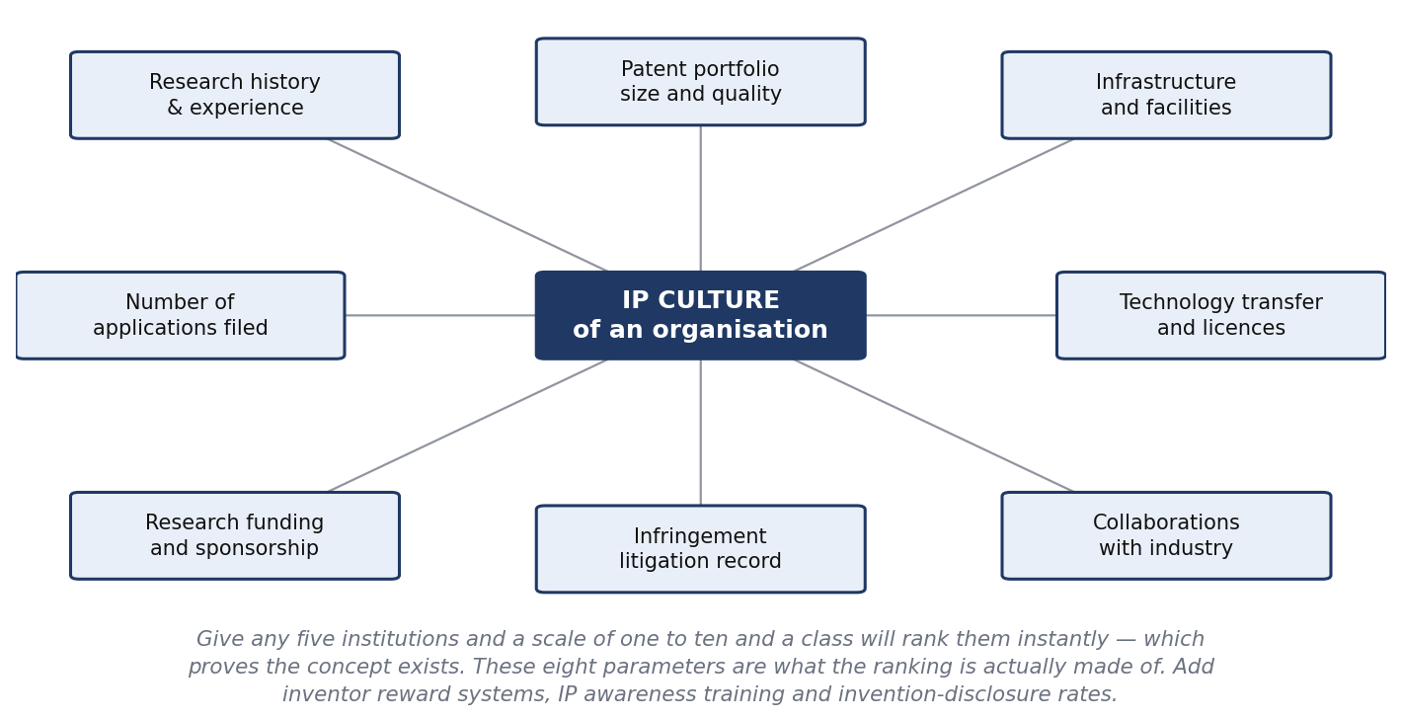
Figure 1.7 The parameters behind an intuitive ranking of IP culture.
The eight parameters are: research history and experience; patent portfolio size; infrastructure; number of applications filed; technology transfer and licences; research funding; infringement litigation; and collaborations with industry. Three more can be added because they measure culture rather than output: the invention-disclosure rate per researcher, inventor reward systems, and IP awareness training. Behind all of them is one summary measure — wealth generated from intellectual assets.

Benchmarks to quote
Institution | Numbers | Point it proves
Stanford | Held the PageRank patent (Larry Page). Licensed it to Google for 1.8 million shares, sold in 2005 for about USD 336 million. Also held the Cohen–Boyer recombinant DNA patents: 468 licensees, about USD 35 billion of product sales, USD 255 million licensing revenue to end-2001 | A university can be a main player in the knowledge economy. Taking equity (about 2%) beat taking a royalty
MIT (FY2025) | About 684 disclosures, 282 US patents issued, 137 licences, USD 60.9 million licence revenue; about 53% of the portfolio licensed or optioned | The 53% is the real measure. The portfolio is used, not just stored
IIT Kharagpur | About 450 patents filed, 120 granted, 7 licensed, 40 copyrights, 60 technology transfers (cumulative) | Good filing culture, narrow commercialisation neck. Look at licences ÷ grants
AUTM (USA, FY2024) | 26,196 disclosures; 9,507 licences; 775 new products; 941 start-ups; USD 109.7 billion research spend | The standard benchmark survey, and the funnel in aggregate
Table 1.2 Always give the year with the figure. The IIT Kharagpur numbers are an undated cumulative snapshot, so call them approximate.
The Cohen–Boyer case — the whole syllabus in one story
Stanley Cohen at Stanford and Herbert Boyer at the University of California worked separately, one on a cutting enzyme and one on the joining technique. They had never collaborated. Both spoke at a conference and it was reported in the press. Niels Reimers, who ran Stanford's technology licensing office, read the report, saw that the two halves together made a platform technology, and proposed patenting it. Scientists objected that a technology able to cut and join genes could be misused. Reimers did not ignore them and did not drop the filing. He called them together and produced a policy on genetic experiments. The objection then disappeared and the patent was granted. Commercialisation needed a different person: the venture capitalist Robert Swanson, who kept asking Boyer for a meeting until he got one. Out of that meeting came Genentech and the first recombinant human insulin, marketed by Eli Lilly.
Use this case for many answers. IP culture: an officer who reads the newspaper. Policy: answer an objection by writing rules, not by refusing. Non-proprietary thinking: a platform licensed to 468 companies, not closed to one. Complementary assets (Teece): the university had the invention, Genentech had the development skill, Eli Lilly had the marketing — all three were needed.

Measuring intellectual capital
Framework | Author, year | What it does
Skandia Navigator | Edvinsson & Malone, 1997 | First corporate IC report. Five focus areas — financial, customer, process, renewal and development, human
Tobin's q | James Tobin | Market value ÷ replacement cost of assets. A high q means the market is paying for intangibles
Intangible Assets Monitor | Sveiby | External structure, internal structure, individual competence
Balanced Scorecard | Kaplan & Norton, 1992 | Financial, customer, internal process, learning and growth
VAIC | Ante Pulic | Efficiency of human capital, structural capital and capital employed, from published accounts
Technology Broker | Annie Brooking, 1996 | Market assets, human-centred assets, IP assets, infrastructure assets
Table 1.3 Name the author and the year. That is what separates a good answer from a vague one.
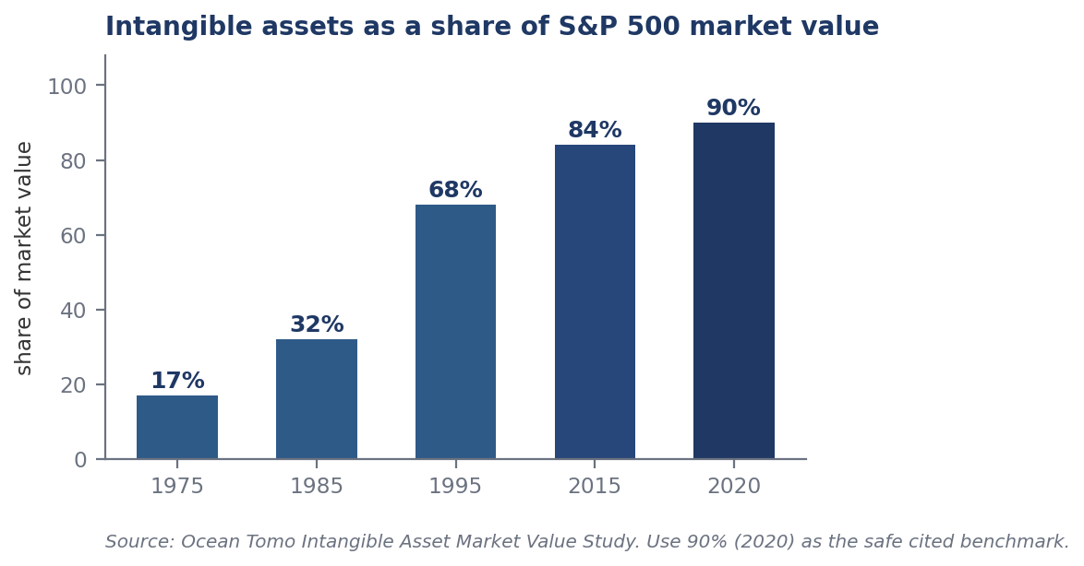
Figure 1.8 The most-quoted evidence that intangibles now dominate company value.
Intangibles rose from 17% of S&P 500 market value in 1975 to 68% in 1995 and over 90% by 2020. Quote 90% for 2020 as the safe figure. Ocean Tomo's own later estimate of 92% should be attributed to them, because they use their own method.
Why does no framework settle the question? Three reasons. Value is very skewed — a few assets carry most of the worth. There is usually no market, so no comparable prices exist. And value depends on things outside the asset, such as who owns the factory and how much term is left.
Correction: the “10 per cent” claim
Do not say “90 per cent of patents are worthless”. Say instead: value is concentrated. The top 10 per cent of a portfolio holds roughly 80 to 85 per cent of its value (Scherer & Harhoff, 2000). The PatVal-EU study of 2005 found only about 7 per cent of patents worth more than €10 million. This is why pruning a portfolio creates value instead of merely saving cost.

What an IP culture costs
- One Indian patent: roughly ₹1 lakh in professional fees as a working average (search, drafting, filing, examination request, first reply). Government fees are extra and depend on whether you are an individual, start-up, MSME or company.
- International cover: one PCT application keeps the option open; the money goes out at the national phase — translation, local agents, and there are about 180 Paris Convention countries.
- Annuities: payable every year, in every country, for up to 20 years. This is what makes an unused patent a standing liability.
- People: a global IP team may be only about 15 people, with drafting and prosecution outsourced.

1.4 In Search of a Paradigm Shift from “Intellectual Property” to “Intellectual Capital”
Note the words “in search of”. This is a claim with evidence, not a settled fact. Say so in your answer.
A paradigm is the standard accepted structure — the assumptions and methods a community takes for granted. The word in this sense comes from Thomas Kuhn, The Structure of Scientific Revolutions (1962). A paradigm shift is when those assumptions themselves are replaced.
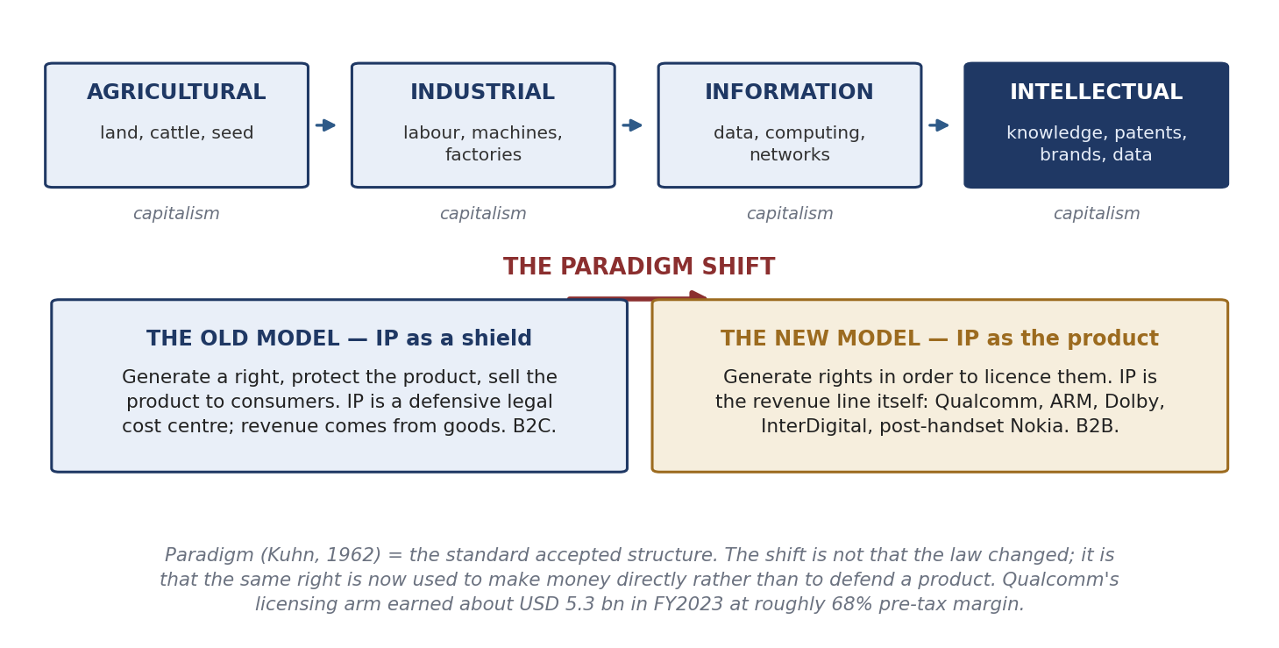
Figure 1.9 The four stages, and the shift inside the last one.
The economy passed through four stages. In the agricultural stage wealth was land, cattle and seed — dowry was counted in cows. In the industrial stage it was labour and machines. In the information stage it was data and computing. Now it is knowledge and the rights that fence knowledge. Granstrand calls this last stage intellectual capitalism: an economy where creating intellectual capital and intellectual property is the heart of value creation.

What actually changed
The law did not change. The purpose changed.
- Old model. Create IP to protect a product, then sell the product to consumers. IP is a defensive cost. Revenue comes from goods. Business-to-consumer.
- New model. Create IP in order to licence it. IP is the revenue line itself. Business-to-business.
The class phrase is the easiest to remember: earlier firms generated property to protect themselves; now they generate property to make property.
Evidence, with figures. Qualcomm's licensing arm earned about USD 5.3 billion in FY2023 — only about 15% of revenue, but at roughly 68% pre-tax margin, so it produces a far larger share of profit. IBM's IP and licensing income averaged around USD 1 billion a year after 1996 and peaked near USD 1.7 billion in 2000. ARM, Dolby, InterDigital and Nokia after it left handsets are further examples. A second consequence is the rise of firms that own rights without making anything: non-practising entities, patent assertion entities, patent brokers and IP marketplaces.
Keep the two meanings of “intellectual capital” apart
Innovation sense: the stock of knowledge resources — people, systems, relationships — from which new value is created. This is the sense used in Unit 2.
Accounting sense: intangible capital expressed in money and brought into a valuation or balance sheet. Same words, different thing. Say which one you mean.

How to answer “Discuss the paradigm shift”
Define paradigm and paradigm shift (Kuhn, 1962). Give the four economic stages. Say what changed in one sentence: from IP as a shield around a product to knowledge as capital, held to be measured, managed and monetised. Prove it with Qualcomm FY2023, IBM, and the rise of NPEs. Name Granstrand's intellectual capitalism as the theory. Then be honest: the shift is uneven, most firms still exploit internally, and the heading itself says “in search of”. Close by separating the two meanings of intellectual capital.

Unit 2 — Intellectual Capital and Knowledge Economy

2.1 Intellectual Capital and the Knowledge Economy
A knowledge economy is one where wealth is created mainly by knowledge, not by land, labour or machines. The term was popularised by the OECD report The Knowledge-Based Economy (1996). Peter Drucker coined “knowledge worker”; Machlup (1962) and Bell (1973) wrote the earlier groundwork.
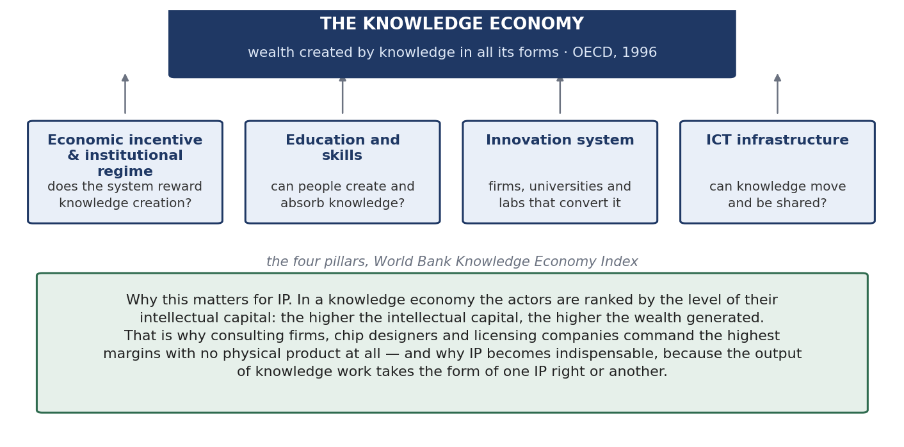
Figure 2.1 The four pillars used by the World Bank to measure a knowledge economy.
The four pillars are: an economic incentive and institutional regime (does the system reward knowledge creation — this is where IP law sits); education and skills; an innovation system of firms, universities and labs; and ICT infrastructure. A country strong in skills but weak in incentives will export its talent. A country strong in incentives but weak in its innovation system will hold rights nobody commercialises.
The neighbouring labels appear in questions as distractors, so note them in one line each: a mixed economy combines private enterprise with State direction; a market economy leaves allocation to market forces; a command economy leaves it to the State; blue and green economies concern ocean resources and sustainable growth; a data economy is the sub-case where data are the main input.

The parts of intellectual capital
Component | What it is, with the class illustration
Human capital | Knowledge, skills and experience of people — students, faculty, lab staff, technicians. Indian institutions are strong here
Structural / infrastructure capital | Processes, systems, records, laboratories, instruments, databases. Also strong on an IIT campus
Relational capital | Value in networks — with industry, government, alumni. The test: when you need a panel, an instrument or a dataset, can one phone call get it?
Innovation capital / potential | The capacity to produce the next asset. It is the result of the other components working together
Cognitive capital | How fast and how well a problem is processed. A hundred people solve one problem a hundred ways; some take two steps, some take ten
Conative capital | The will to act — drive, initiative, persistence. Deciding to take the step instead of analysing it further
Affective capital | How passionate people are about the work. It shows in a presentation as clearly as in a lab
Table 2.1 The first three are the standard published taxonomy. Cognitive, conative and affective come from the classical psychology triad — thinking, willing, feeling.
The examinable conclusion
Everybody has human, structural and relational capital, and Indian institutions genuinely have them in strength. What makes one organisation different from another is the last three — cognitive, conative and affective — because they decide whether the first three are actually converted into output. Short version: the first three explain capacity; the last three explain conversion. Together they produce innovation potential.

Two structural points to remember. Organisational capital = intellectual capital + financial capital. And in a knowledge economy IP is indispensable most of the time, because the output of knowledge work almost always takes the form of some IP right — but not always, and you should say so, because every rule has an exception.

2.2 Transforming IP into Intellectual Capital in a Competing Economy
The heading does not ask how IP is created. It asks how IP is turned into capital. That is a pipeline with money going in on one side and coming out on the other.
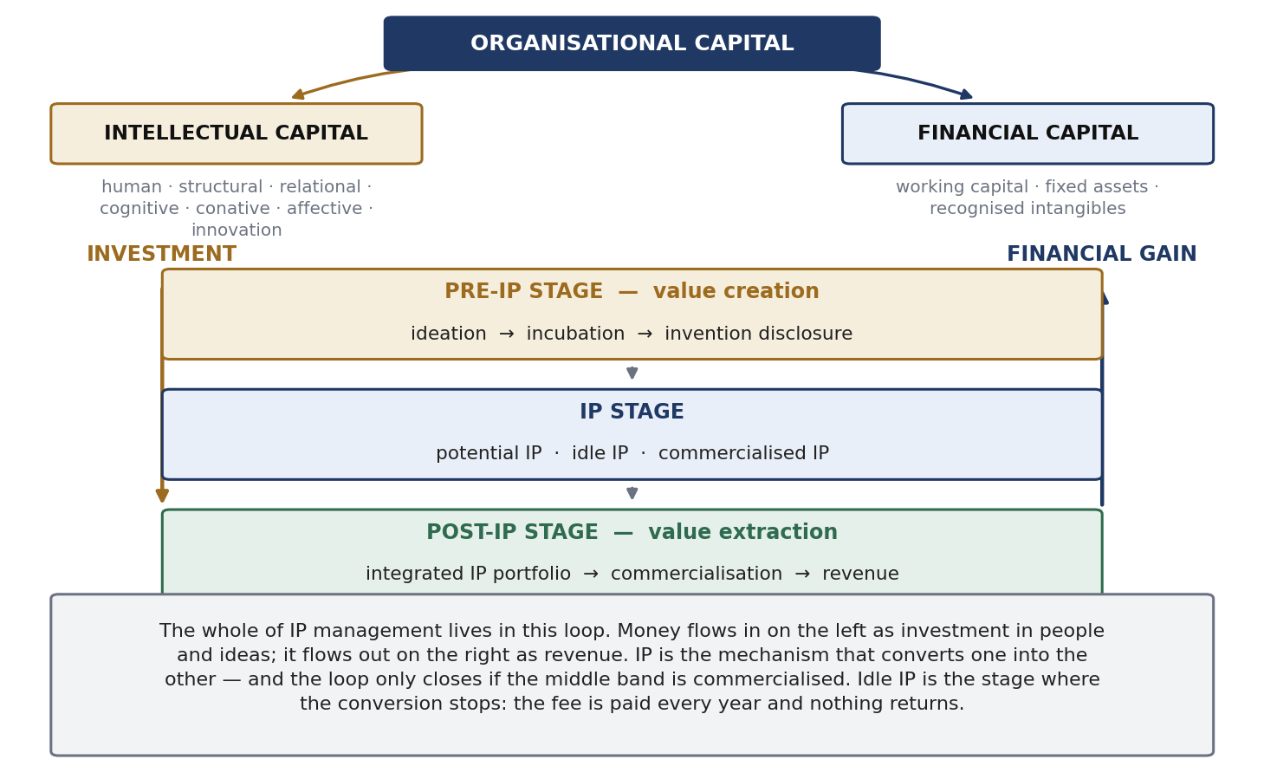
Figure 2.2 Investment on the left, financial gain on the right, and three stages in between.
- Pre-IP stage — value creation. Ideation, incubation, invention disclosure. Nothing is protected and nothing is earning. Money only goes out.
- IP stage. The asset exists and is in one of three conditions: potential IP, idle IP, or commercialised IP.
- Post-IP stage — value extraction. The assets become an integrated portfolio, are commercialised, and turn into money.
The key point: the loop only closes if the middle stage reaches the third condition. Idle IP is where the conversion stops — the annuity is paid every year and nothing comes back. There is a second silent loss too: leakage of proprietary technology through weak confidentiality, leaky suppliers or staff who leave. Surveys suggest firms lose about as much technology as they deliberately sell.

How it happens in practice: the funnel
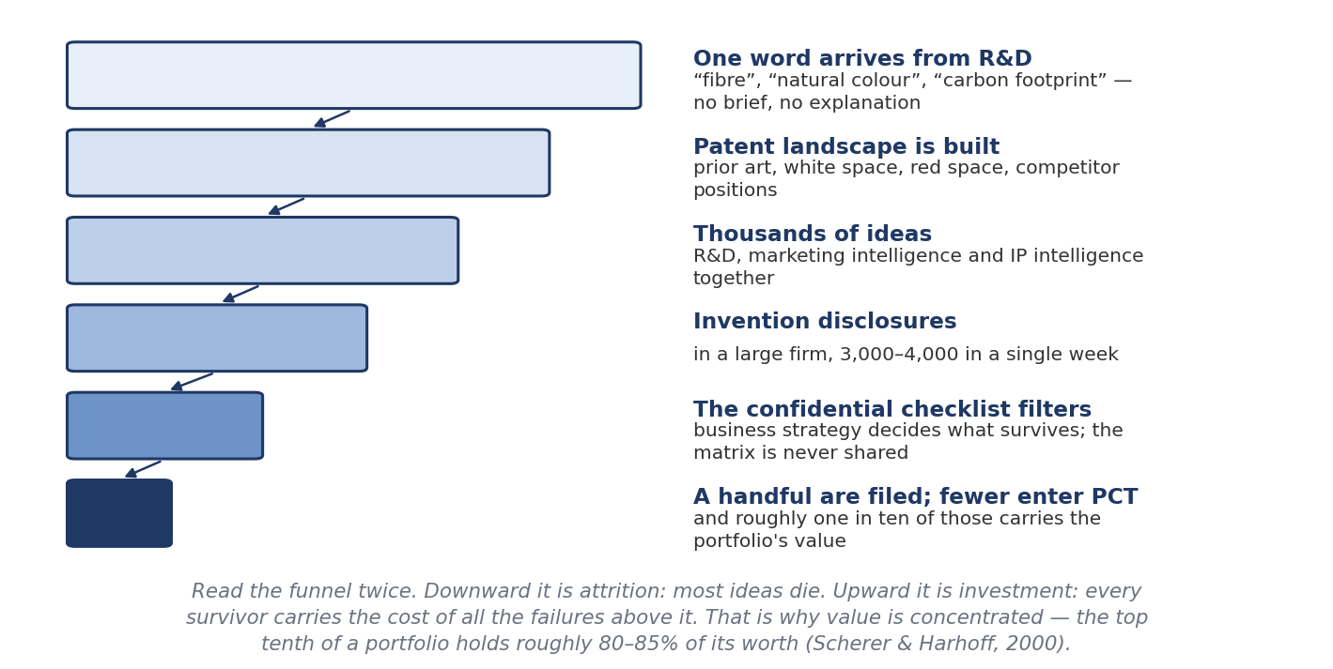
Figure 2.3 From a one-word brief to a granted family.
The class described the real process. An analytics team gets an email with one word in it — “fibre”, “natural colour”, “carbon footprint” — and no explanation, because they are expected to know the company. From that word they build a patent landscape: a bird's-eye view of the technology from patent data, showing prior art, trends, applicants, and which areas are crowded (red space) or empty (white space). Parameters may number five or sixty.
The landscape goes to R&D, marketing intelligence and senior managers. Together they generate thousands of ideas. These are filtered against a checklist kept confidential to the team. In a large firm, invention disclosures arrive at 3,000 to 4,000 a week. Only a handful are filed, fewer enter the PCT, and about one in ten of those carries the value.
- Landscape vs FTO. A patent landscape is broad and strategic; a mistake is survivable. A freedom-to-operate search asks whether one product can be sold in one market without infringing; one missed reference can be fatal.
- Themescape. A way of drawing patent clusters as a topographic map, with hills where activity is dense. It shows cross-pollination — a compressor improvement made for refrigeration being used somewhere else.
- Databases named in class: Derwent and Clarivate, Questel Orbit, Delphion, Thomson Innovation, STN.
A favourite question: which drives which?
Does IP analysis drive business strategy, or does business strategy drive IP analysis? Business strategy drives. It is the umbrella. When the board decides to enter automotive sensing, inventions in that area suddenly pass a filter that used to reject them. The IP function informs the decision with landscapes and intelligence, but it does not make it.

Why India's conversion is low
India is very rich in intellectual capital but creates much less wealth from it. Three reasons, and each maps onto a component of Table 2.1.
- Where the business sits. Wealth is created where the commercialising company is. If the technology companies are abroad, the first filings and the value are abroad too. Non-resident filings have historically dominated Indian patent applications, though the resident share is rising.
- Structural capital. A researcher who never had the instruments cannot produce the same work. The same person in a different infrastructure produces different output. This is not a shortage of intellectual capital but of the conditions to convert it.
- The type of innovation. More incremental and reverse-engineering work than frontier invention, which follows from the first two.
The response is infrastructure, not exhortation. Large firms build it deliberately: internal collaboration platforms where employees post projects and find collaborators, town halls, and informal Friday events whose real purpose is to break hierarchy so that ideas move.

2.3 Ideas and IPR in the Determination of Economic Growth
This is an economics question: do ideas and the rights over them actually cause growth? There is a canonical answer and you should name it.
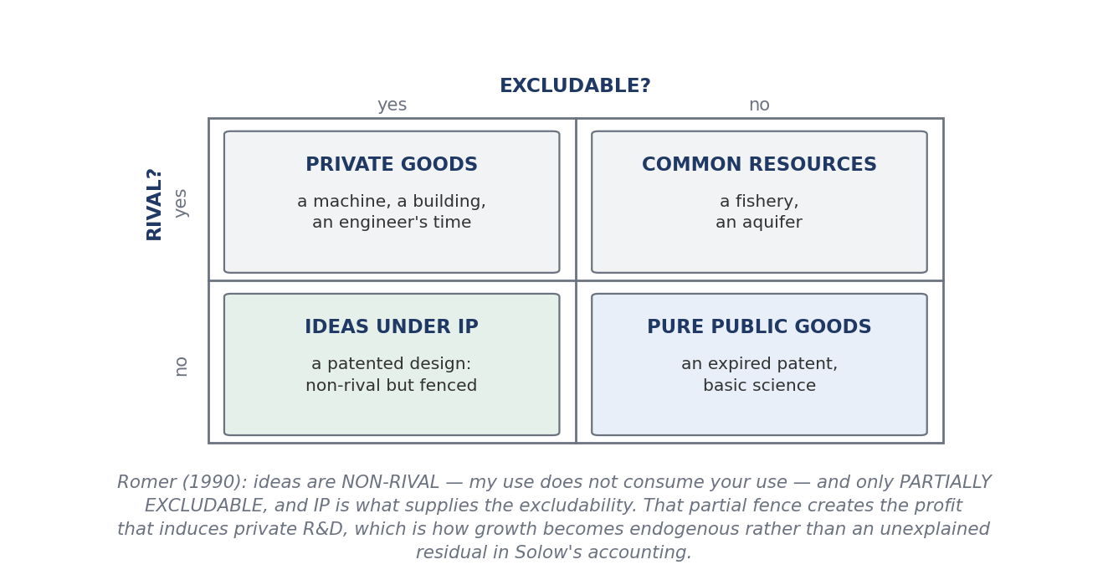
Figure 2.4 The two properties of ideas that make growth endogenous.
Paul Romer, “Endogenous Technological Change”, Journal of Political Economy (1990). Ideas have two special properties:
- Non-rival. My use of an idea does not use it up. Any number of people can use the same design at the same time, at almost no extra cost.
- Partially excludable. Others can be kept out, but imperfectly — and intellectual property is exactly what supplies that exclusion.
What follows: because a non-rival input can be used at near-zero marginal cost, perfect competition cannot hold; the market becomes monopolistic competition. Partial excludability then creates the profit that makes private research worth doing. So growth is generated inside the model by deliberate investment in R&D — endogenous — instead of appearing as the unexplained residual in Solow's growth accounting. That is the precise sense in which IPR determines growth: it turns a non-rival good into a partly appropriable one, and appropriability causes the investment.

The disclosure problem
Kenneth Arrow (1962) described the information paradox: a buyer cannot value information without seeing it, but once he has seen it he already has it and need not pay. So information markets fail unless something fixes them. The patent bargain is one fix — full disclosure in exchange for a limited right to exclude. The system therefore serves two incentives: the incentive to invent and the incentive to disclose.

The debate — give both sides
Position | Argument
For — Kitch (1977), prospect theory | A patent works like a mineral prospect. Giving one party early control makes that party coordinate and develop the downstream applications efficiently, avoiding wasteful duplicate racing
Against — Heller & Eisenberg (1998), Science 280: 698 | The anticommons. Too many fragmented overlapping upstream rights mean everyone can block, so the resource is underused. It is the mirror image of the tragedy of the commons, and it blocks cumulative innovation
Against — empirical critics | Moser, Lerner, and Boldrin & Levine (Against Intellectual Monopoly, 2008) argue the historical evidence that patents drive innovation is much weaker than the theory claims
Table 2.2 The Park–Ginarte index and Kanwar & Evenson are the standard attempts to measure IPR strength against growth.
For empirical weight, use the USPTO series. The third edition (2022, using 2019 data) found 127 IP-intensive industries accounting for USD 7.8 trillion, or 41% of US GDP, and 44% of employment. This is the corrected version of the “27 per cent” figure often quoted in class notes — that was 27.7% on 2010 data from the 2012 edition. Quote the movement from 27.7% to 44%, not either number alone.
Finally, growth needs diffusion as well as invention. Adoption follows an S-curve: a few leaders adopt, the market watches, then adoption accelerates and saturates. And two frictions are worth naming. Technology moves faster than law, so an Act can be out of date before it is enforced. And the patent term is debated — if a technology is obsolete after 20 years, what does the public domain gain? The answer: an expert reading an expired specification gets the detail, and the disclosure has been public since publication, not since expiry. The counter-argument is that firms keep the truly critical layer as a trade secret and patent only the periphery.

2.4 IP and Intellectual Capital: the Role of Non-Proprietary Technologies
The question here is simple: can a technology create huge value without being exclusively owned? The answer is yes, and working out why tells you what ownership actually contributes.
The distinction that decides marks
Non-proprietary does NOT mean unowned. Linux is copyrighted. Android is owned by Google. Wikipedia's content is licensed, not ownerless. What makes them non-proprietary is that the owner chose to licence openly instead of excluding. So value lies in adoption, not in ownership — and the same strong right can be used either to open a technology or to close it.

- Public domain — rights have expired, lapsed, or never existed.
- Open source — licensed so that anyone may use, study, modify and redistribute.
- Freeware — only free of cost. It may be completely proprietary.
- Open standard — a specification available to all implementers on defined terms.
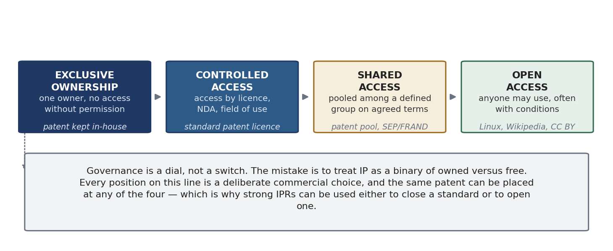
Figure 2.5 Governance is a dial, not a switch. The same patent can sit at any of these four points.
Example | What it shows
Linux, Apache | Foundational infrastructure. Companies make money on top by selling support, distributions and services
GitHub | The value is the network of contributors, not any one repository
Android / Open Handset Alliance | An open base created an entire device industry; the sponsor monetises services and the store
Raspberry Pi | Almost every IoT idea is prototyped on it. The final product ships with a custom controller, but the invention happened because the Pi existed
Wikipedia | Replaced a subscription encyclopaedia industry using volunteers and open licences — and did it with a very carefully drafted governance and liability framework
Human Genome Project, Bermuda Principles | An attempt to enclose the sequence was rejected in favour of daily public release. Open release accelerated a whole field
CSIR's Open Source Drug Discovery | Open collaboration used where the market fails — diseases of the poor attract little private money
Tesla patent pledge, 2014 | An incumbent opening its portfolio to grow the ecosystem it depends on, not out of generosity
Table 2.3 Pair each example with the mechanism it illustrates. Do not just list them.
Licences must be described accurately. Creative Commons is built from four elements: BY (attribution), NC (non-commercial), SA (share-alike), ND (no derivatives), combined into six licences. A CC BY-NC-SA licence allows reuse with credit, for non-commercial purposes, on the same terms — so it does not permit commercialisation. In software, the GPL is a copyleft licence whose conditions pass to derivative works; MIT and Apache 2.0 are permissive, and Apache 2.0 also grants an express patent licence.
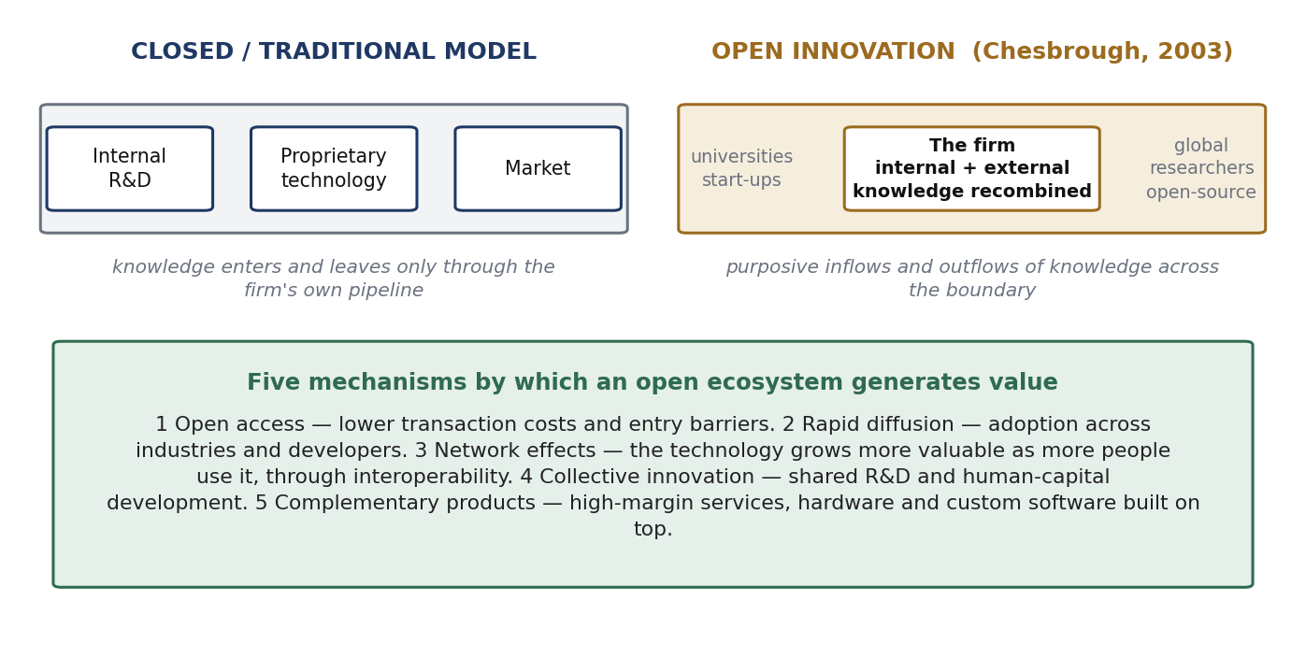
Figure 2.6 Closed and open models, and the five ways an open ecosystem creates value.
Henry Chesbrough (Open Innovation, 2003) defined the open model as the purposeful use of inflows and outflows of knowledge to speed up internal innovation and widen the market for external use of innovation. Firms can and should use outside ideas as well as their own. Eric von Hippel (Democratizing Innovation, 2005) added that users, not manufacturers, are often the source of the innovation.
Firms still make money without exclusivity, through support and subscriptions, dual licensing, hardware, data and advertising, and complementary services.
The counter-case and the balancing principle
Open does not always work. Free-riding is real, appropriability is weak, governance often fails, and most successful open platforms keep a proprietary layer anyway. Liability is a serious issue too: an operator who cannot control every input must still be protected from being blamed for it, which is why Wikipedia has such detailed policies and why Indian law protects intermediaries from liability for user content.
The balancing principle is the best closing line: IP exists to deliver social benefit + the inventor's benefit + technological development. Where exclusivity serves all three, use exclusivity. Where it obstructs the first and third — genomic data, a neglected disease, an infrastructural standard — the open route serves the same purpose better. Non-proprietary technology is not the opposite of IP; it is a different setting of the same dial.

2.5 Identifying the Objectives, Purpose and Players
Before writing a policy you must answer three questions: what are we trying to achieve with IP, why are we managing it, and who has a stake?

Objectives — what a right is held for
You must always be able to say what a particular patent is FOR, because the purpose decides how the claims are drafted and where the family is filed. A defensive patent and a revenue patent are drafted differently even on the same invention.
Objective | In practice
Exclusion | Stop competitors selling a competing product. The classic use
Revenue | Licence for royalties, or assign for a lump sum
Freedom to operate | Hold rights so others' rights can be neutralised by exchange instead of litigation
Cross-licensing currency | Hold a portfolio to trade, so an assertion can be met with a counter-assertion
Defensive publication | Publish so nobody else can patent it — accepting that you cannot either
Signalling | Show technical capability to investors, partners and ranking bodies
Standard setting | Put your technology into a standard so every implementer needs a licence
Blocking | Deny a competitor a route you do not use yourself
Attracting funding | Sponsors and investors need ownership clarity before they commit
Table 2.4 Most portfolios serve several objectives at once, and different assets serve different ones.
Purpose differs by institution. A corporation wants appropriated value (wealth). A university wants use of the technology plus a share of the value, plus ranking and reputation. A public research body wants the technology diffused into national use, subject to security. All three create IP; they are not trying to do the same thing with it.

The players
Role | Internal | External
Create | Inventors, researchers, students, R&D | Collaborating institutions, consultants, users
Decide | Board, director or dean, IP cell or TTO | Sponsors, funding agencies, standard-setting bodies
Advise and process | IP legal, business development, finance | Patent agents and attorneys, patent offices, valuers
Exploit | Product divisions | Licensees, assignees, spin-outs, JV partners
Constrain | Compliance and conflict-of-interest committees | Competitors, regulators, courts, government, the public
Table 2.5 Group players by what they do, not by seniority.
Two tools structure the analysis. Mendelow's power–interest matrix (1991) sorts stakeholders by power and interest into four treatments: manage closely, keep satisfied, keep informed, monitor. The salience model of Mitchell, Agle and Wood (1997) sorts by power, legitimacy and urgency — useful because it explains why a student inventor, who has a legitimate claim but no power, gets ignored until a policy forces attention.
Worked example: who owns what comes out of a hackathon
Players: the sponsors (often tiered primary, secondary, gold); the giver of the problem statement, which may be a government agency or a company; the participants, whose teams may come from several institutions; and the organising institute, which gives effort, premises and resources. Issues to settle in advance: prize money, ownership of the problem statement, ownership of any IP created, incubation, resource use, and monetisation including equity.
The conclusions: sponsorship is an advertising deal and should not by itself carry ownership of participants' IP, because a competition that claims the IP will attract nobody. The problem-statement giver may keep rights in the statement but not in the solution. The organising institute cannot claim sole ownership when participants come from other institutions that may claim over their own students. The workable answer is to attach ownership consequences to incubation, not to entry. The Y Combinator model is cleanest — take a small equity stake and no interest in the IP. Equity in the company, not rights in the patent.

2.6 IP Policies — Top-Down and Bottom-Up Approach
Definition
A policy is a set of guiding principles by which an organisation decides in advance how it will answer its routine, recurring questions — so that when an issue arises, the answer is given by reference to the policy instead of being argued again. Roughly 80 per cent of day-to-day questions can be settled this way, which leaves judgement free for the rest.

Why an IP policy is required — four reasons
- It states the vision and aim, which in IP is usually maximum wealth creation from the institution's intellectual assets.
- It keeps the process consistent, so people and circumstances change but the process does not.
- It fixes the revenue-sharing model in advance, removing the most contentious question from case-by-case bargaining.
- It defines rights and duties. The inventor's duty is to disclose; the inventor's right is a share of what it earns.
Two more purposes are worth adding. A policy communicates outward, telling industry and sponsors where the institution stands, almost like a prospectus. And it protects the institution's own investment — without it, the salaries, infrastructure and resources the institution supplied are quietly subsidising outcomes it has no claim to.

Where a policy sits among legal instruments
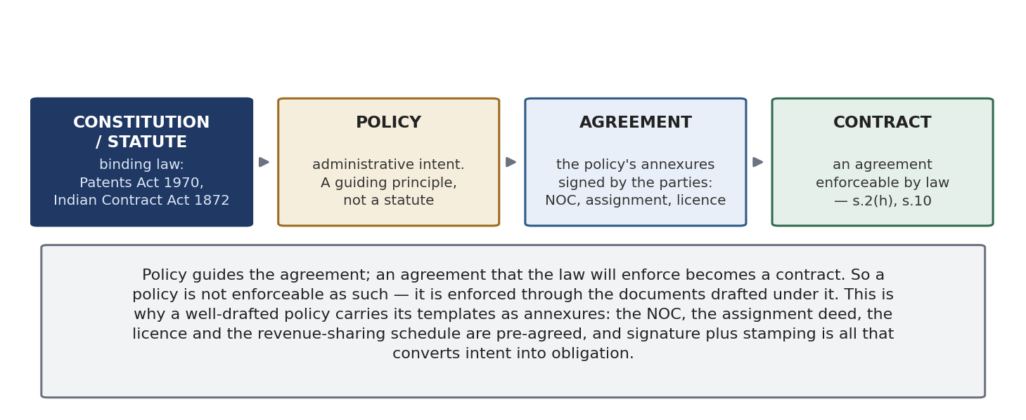
Figure 2.7 From binding law, through administrative intent, to enforceable obligation.
A policy is not a statute and is not enforceable by itself. An Act is binding law. A policy is administrative intent — a guiding principle. Guidelines implement it at the working level. An agreement records consent, and an agreement enforceable by law is a contract (s.2(h) and s.10, Indian Contract Act 1872).
So the chain is: policy guides the agreement, and the enforceable agreement becomes a contract. This has a practical drafting consequence. A good IP policy attaches its documents as annexures — the NOC, the assignment deed, the licence, the confidentiality undertaking, the revenue-sharing schedule — so that signature and stamping are all that is needed to turn intent into obligation.

The two approaches
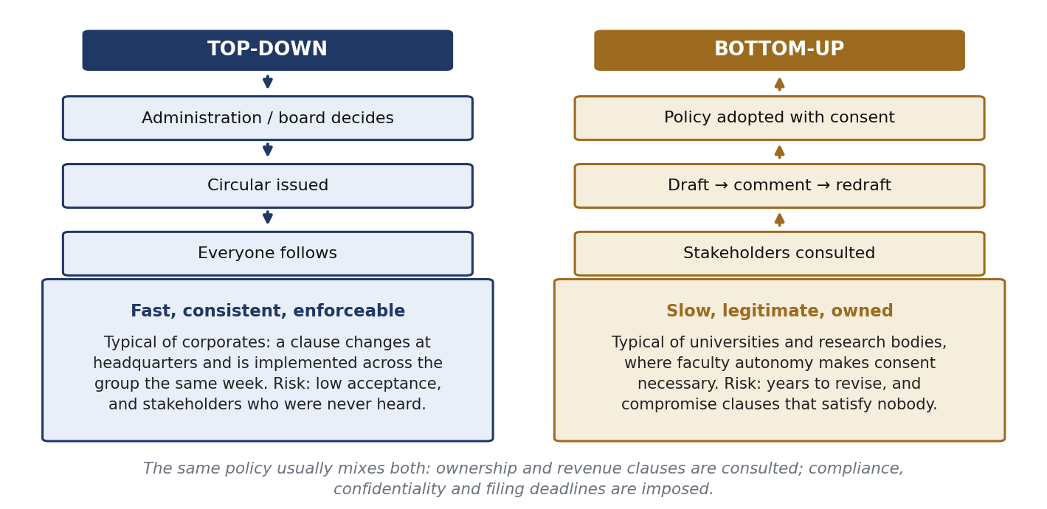
Figure 2.8 Top-down and bottom-up policy formation.
 | Top-down | Bottom-up
How it works | Administration decides, a circular is issued, everyone follows. No ratification or consent | Stakeholders are consulted; draft, comment, redraft, deliberate, then adopt
Typical user | Corporations — a clause can change in a week | Universities and research bodies, where faculty autonomy makes consent necessary
Merits | Fast, consistent, enforceable | Legitimate, accepted, owned by the people it governs
Risks | Low acceptance; people who were never heard comply minimally | Very slow; compromise clauses that satisfy nobody
Table 2.6 These are clause-level choices, not institution types. Most real policies mix both.
In practice ownership and revenue clauses are consulted, because they affect the inventor directly; confidentiality, disclosure duties and filing deadlines are imposed, because consultation adds nothing to a compliance rule.
A policy must also be versioned. It should change as law, technology, funding and priorities change, and every case that arises should be written back into it. A policy dated 2015 and never revised is itself a finding about the institution's IP culture.
At the national level, India's National IPR Policy 2016 (approved 12 May 2016; slogan “Creative India; Innovative India”) sets seven objectives: IPR awareness and outreach; generation of IPRs; a strong legal and legislative framework; administration and management; commercialisation of IPR; enforcement and adjudication; and human capital development. WIPO also publishes a model IP policy for universities.
A drafting lesson worth a mark
A policy drafted for a national digital library was returned because the stakeholders could not understand it. It had to be rewritten in language a librarian, a student or a researcher could actually read. A policy is not a place to display good English. A rule nobody understands is a rule nobody follows.

2.7 Defining IP Policy for a Corporation, a University and Research Organisations
This section takes the policy apart clause by clause, then shows how the same clause is written differently by the three types of institution.

The fifteen-point framework
Learn this as a list. It is the direct answer to “what should an IP policy contain?”
# | Clause | What it must settle
1 | Ownership of IP | Title in every situation — see the decision tree below
2 | Disclosure policy | Who reports what, to whom, how fast. Separate rules for students and for inventors
3 | Confidentiality and assignment | No publishing before filing; and how title actually moves
4 | Assessment of inventions | Who evaluates a disclosure, on what criteria, in what time
5 | Obtaining IPR | Who decides to file, who instructs counsel, who pays
6 | Renewal | Who pays annuities; what happens if the institution stops
7 | Foreign filing | Which countries, and who bears PCT and national-phase costs
8 | Contracts and agreements | The annexed templates and who may sign
9 | Technology transfer | Routes: licence, assignment, spin-out, sponsored development
10 | Revenue sharing | Model, base, disbursement, reassignment, co-creator shares
11 | Infringement, damages, insurance | Who may sue, who pays, who bears the loss
12 | Conflict of interest, inventorship disputes | Consultancy conflicts and rival inventorship claims
13 | Dispute resolution | Internal committee, mediation, arbitration or court
14 | Right to regulate the policy | Who may amend it, and how versions are managed
15 | Jurisdiction | Forum and governing law
Table 2.7 Policies also normally open with objectives, definitions and applicability.

Clause 1: ownership
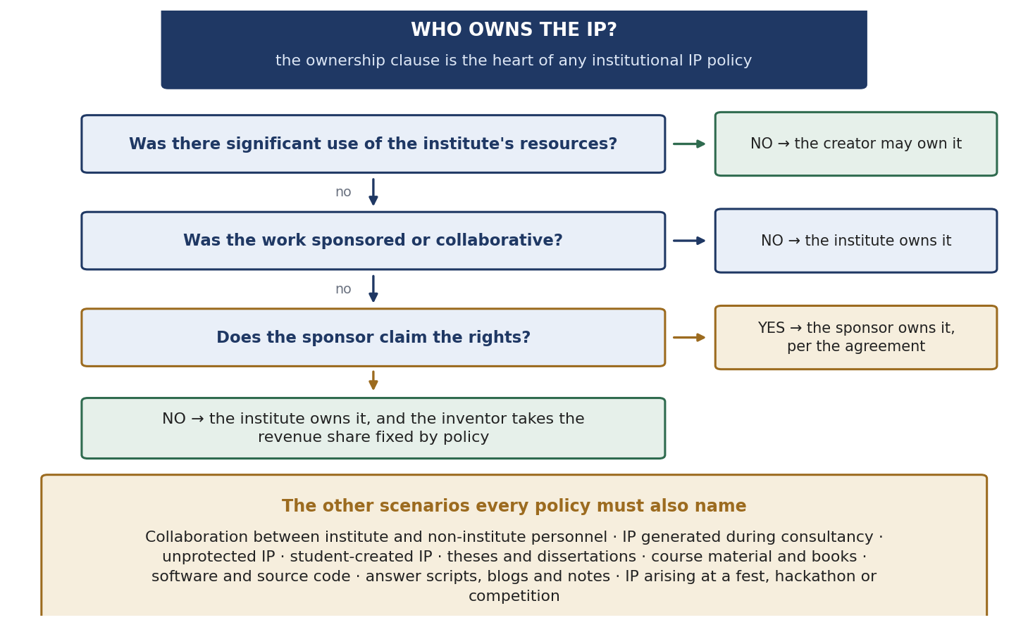
Figure 2.9 The ownership decision, and the situations a policy must name.
The main test is the use of institutional resources. No significant use — the creator may own it. Significant use of labs, instruments, funded staff or infrastructure — the institution owns it. Sponsored and collaborative work follows the sponsoring agreement, and the policy must say what happens if the sponsor does NOT claim (usually the institution takes it).
A policy must also name the situations people forget: collaboration between institute and non-institute personnel; IP generated during consultancy; unprotected IP such as know-how and data; student-created IP; theses and dissertations; examination answer scripts (the student's copyright); course material, books, blogs and lecture notes; software and source code; and anything created at a fest, hackathon or competition.

Clauses 2 to 9: disclosure, protection and cost
Disclosure is the hinge — an institution cannot manage what it does not know about. Confidentiality runs with it: no publication before filing, which in academia is the single commonest cause of lost rights. Assessment follows, and a good policy adds that if the institution decides not to protect, the rights go back to the creator instead of lying in limbo.
Foreign filing is where the money is. One model described in class: the institute pays for the first ten years, PCT costs are shared 50:50 between institute and inventor, and national-phase costs are borne by the inventor. The deliberate effect is that the inventor has a financial stake in the family, which discourages vanity filings.

Clause 10: revenue sharing
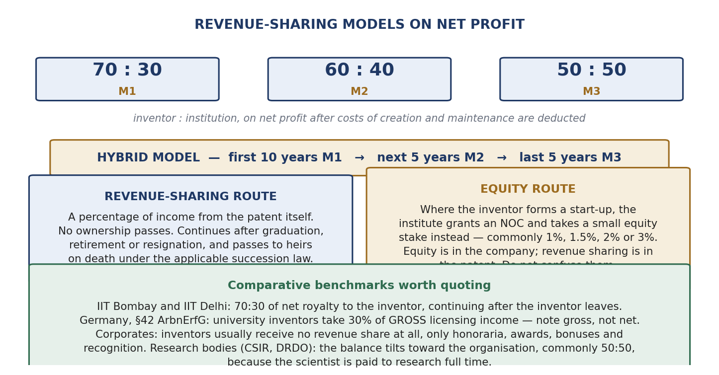
Figure 2.10 The models, the hybrid schedule, and the two routes for a start-up.
- The models. 70:30, 60:40 or 50:50 between inventor and institution, applied to NET profit — the costs of creating and maintaining the right are deducted first. Net versus gross is worth a mark.
- Hybrid model. The ratio changes over the patent's life: for example first 10 years on one model, next 5 on another, last 5 on a third.
- Progressive model. The share changes with the level of income.
- After the inventor leaves. Good policies continue the entitlement after graduation, retirement or resignation for IP created while eligible. On death it passes to heirs — the policy can only say “as the law of the land provides”, because devolution follows succession law.
- Equity instead of royalty. If the inventor starts a company, the institution issues an NOC and takes either a revenue share or equity, commonly 1%, 1.5%, 2% or 3%. Do not confuse the two: equity is a share in the whole company; revenue sharing is a share in one patent's income.

The three institutions compared
 | Corporation | University | Research organisation
Purpose | Wealth for shareholders | Use of technology, a share of value, plus ranking | Diffusion into national use, subject to security
Inventor's share | Usually none. Honorarium, awards, bonus, recognition instead | Substantial — 70:30 net at IIT Bombay and IIT Delhi | Tilted to the organisation, often about 50:50, as the scientist is paid to research
Policy direction | Mostly top-down; clauses change quickly | Mostly bottom-up for ownership and revenue | Mixed, with statutory and security limits
Start-ups by creators | Usually barred or tightly controlled | Allowed with an NOC and an equity or revenue election | Often restricted or not permitted
Table 2.8 This table is the direct answer to the syllabus heading.
Why do corporate inventors get nothing? Not unfairness — arithmetic. A company cannot create an open-ended royalty liability across tens of thousands of patents, so it substitutes recognition, honoraria, bonuses and visibility, which works well and costs little. Employment terms are correspondingly tight.

Employee inventions in other countries
Country | Rule
USA | Ownership by contract (pre-invention assignment). Gaps filled by the hired-to-invent doctrine and by shop rights (a free non-exclusive licence to the employer where its resources were used)
Germany / EU | Rights vest in the employee inventor first. The employee must notify; if the employer does not release within four months it is deemed claimed. The employee then has a non-waivable right to reasonable remuneration, with arbitration at the German Patent Office. Section 42 gives UNIVERSITY inventors 30% of GROSS licensing income — note gross, not net
Japan | Article 35 of the Patent Act. The Nichia blue-LED case (Shuji Nakamura): the Tokyo District Court awarded ¥20 billion in 2004; it settled at ¥843 million in 2005. The case drove the 2004 reform
India | No dedicated statute. Ownership depends on the employment contract and common law — which is exactly why the institutional policy matters so much here
Table 2.9 A multinational research organisation has to run all four in parallel.
Worked case: two inventors, three friends, one dispute
Two researchers at an institute develop a technology; the institute is the applicant, they are the inventors. They leave, start a company, and hire three friends from the institute. The company files more patents and, because they were friends, all five are named as applicants. The company succeeds and the five fall out over the money. The dispute comes back to the institute because the institute is the applicant on the first patent.
Split it into three questions. (1) The institute's patent: the policy already decides it — 70:30 net, nothing to argue. (2) How the company uses it: assignment transfers ownership; a licence transfers only permission for a time; an NOC is the consent that precedes the start-up. Whichever is chosen is negotiated when the NOC is issued. (3) The company's own patents: all five were named applicants, so all five have rights and each can claim. That is the mistake.
The drafting rule: where a start-up is involved, all rights must be applied for in the name of the START-UP as a legal person, never in the names of individuals. Employees are then inventors bound by service contracts, rewarded with recognition and bonus. Note the distinctions the case tests — inventor (the natural person who conceived), applicant (who prosecutes), assignee (who acquires title); and Form 1 requires the applicant to say whether it is the inventor and, if not, to record the assignment.

2.8 When Rights of Trademark Owners and Domain Name Owners Collide
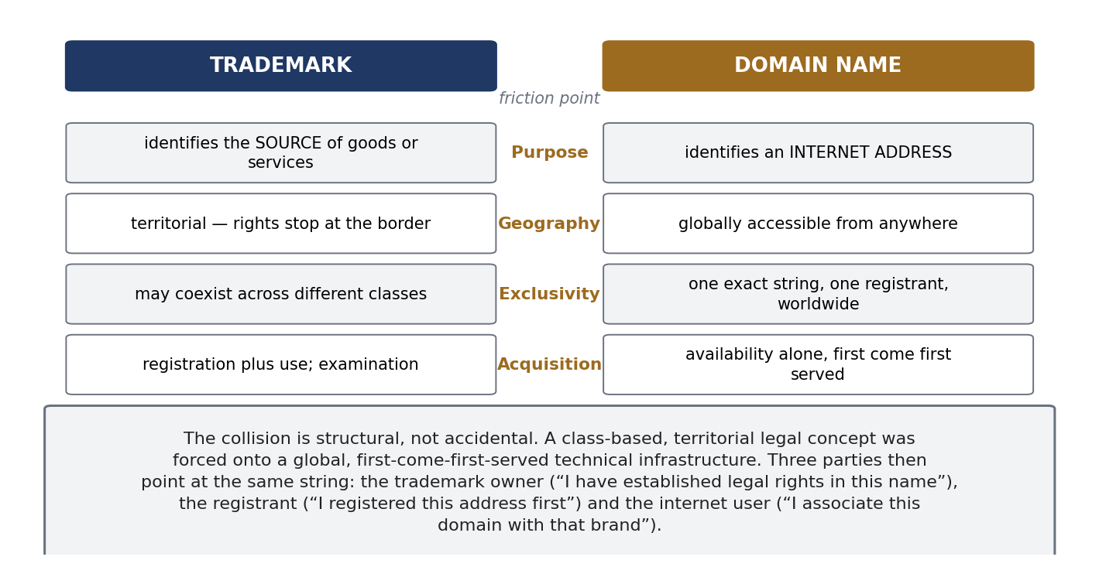
Figure 2.11 Two systems built on incompatible assumptions.
A trademark identifies the SOURCE of goods or services. It is territorial and class-based, so the same mark can coexist in different countries and different classes. It is obtained by registration and use, after examination.
A domain name identifies an INTERNET ADDRESS. It is globally accessible, absolutely exclusive (one string, one registrant, worldwide), and obtained on availability alone — first come, first served, with no examination.
So a territorial, class-based legal concept has been forced onto a global, first-come-first-served technical system. Three parties then point at the same name: the trademark owner (“I have legal rights in this name”), the registrant (“I registered this address first”), and the internet user (“I associate this domain with that brand”). All three statements are true.
The architecture: ICANN oversees the system, registries run each top-level domain, registrars sell registrations. gTLDs are .com, .net, .org and the rest; ccTLDs are country codes such as .in. The abuses have names: cybersquatting (registering a mark to sell it back), typosquatting (misspellings), domain parking (monetising traffic), and reverse domain name hijacking (a trademark owner using the machinery to grab a legitimate holder's domain).

The UDRP
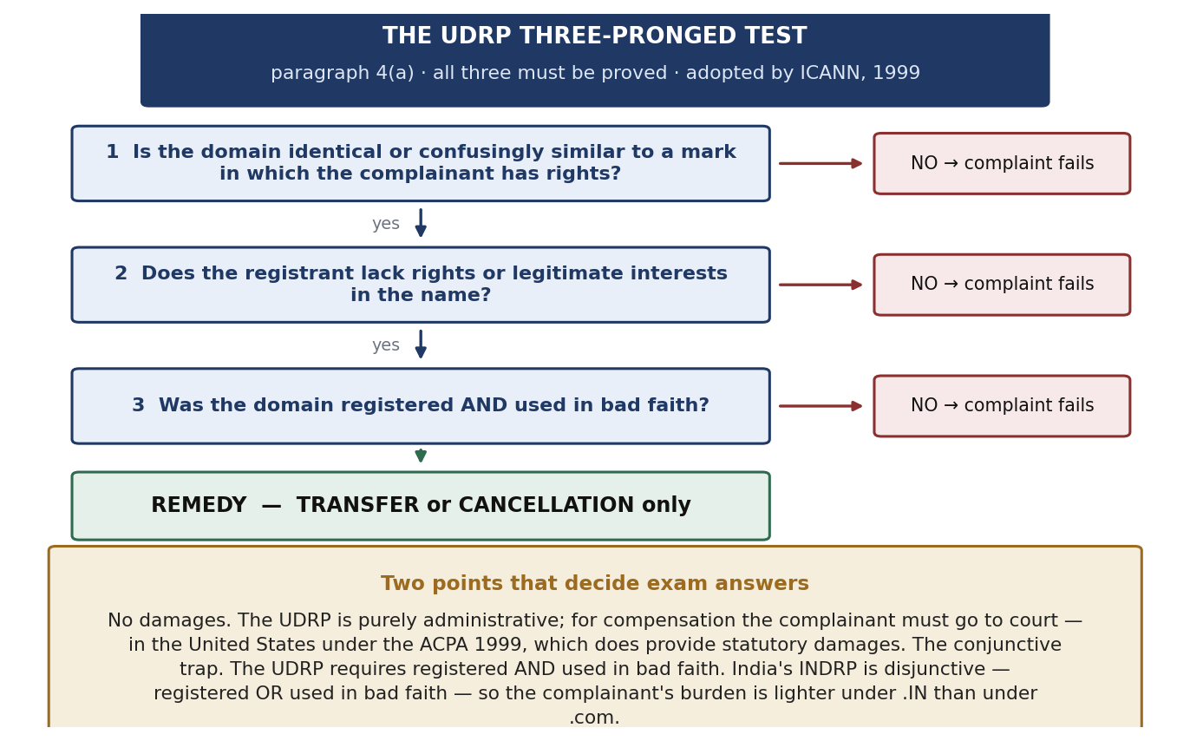
Figure 2.12 The three-pronged test, the failure points and the remedies.
The Uniform Domain Name Dispute Resolution Policy was adopted by ICANN in 1999, with complaints accepted from 1 December 1999 and WIPO as the first provider. Under paragraph 4(a) the complainant must prove ALL THREE:
- The domain name is identical or confusingly similar to a mark in which the complainant has rights.
- The registrant has no rights or legitimate interests in the name.
- The domain was registered AND is being used in bad faith.
Paragraph 4(b) lists bad-faith indicators: acquiring it mainly to sell to the mark owner above cost; a pattern of blocking registrations; registering to disrupt a competitor; and using it to attract users for commercial gain by creating confusion. Paragraph 4(c) lists the defences: bona fide use or preparations before notice of the dispute; being commonly known by the name; and legitimate non-commercial or fair use.
Two points that decide answers
No damages. The remedies are transfer or cancellation only. For compensation you must go to court — in the USA under the ACPA 1999, 15 U.S.C. §1125(d), which does give statutory damages.
The conjunctive trap. UDRP requires registered AND used in bad faith. India's INDRP (for .IN, run by NIXI) is disjunctive — registered OR used. So the complainant's burden is lighter under .IN than under .com. Complainant success rates under the UDRP run at roughly 80 to 85 per cent.

Indian case law
Case | Court, year | Ratio
Yahoo! Inc. v. Akash Arora, 1999 PTC (19) 201 (Del) | Delhi HC, 1999 | India's first cybersquatting case. “yahooindia.com” restrained as passing off. A domain name is a business identifier and gets the same protection as a trademark; adding “India” did not distinguish it
Satyam Infoway v. Sifynet Solutions, (2004) 6 SCC 145; AIR 2004 SC 3540 | Supreme Court, 2004 | The leading authority. No Indian statute governs domain names, but a domain name has the characteristics of a trademark and is protected by passing off. Domain names are global identifiers needing exclusivity, so confusion is more likely
Tata Sons v. Manu Kosuri; Rediff v. Cyberbooth | Delhi HC; Bombay HC, 2000 | Well-known marks cannot be taken as domains; a domain name is a valuable corporate asset
Table 2.10 India has no domain-name statute; the courts use passing off.
Remember also that trademark rights are not absolute. APPLE can be a technology company, a fruit seller, a restaurant and a school at the same time. The formula: protection = distinctiveness + specific goods or services + likelihood of confusion.
The hard case: registered in good faith, commercialised later
Facts. In 2018 Rahul registers greenleaf.com for a gardening blog. In 2021 GreenLeaf Pvt. Ltd. registers the trademark GREENLEAF for agricultural products. In 2024 Rahul starts selling gardening products on the site. Who wins?
Under the UDRP, Rahul wins on the third element. Bad faith must exist AT REGISTRATION, and in 2018 he could not have known of a trademark that did not exist. Later bad-faith use does not cure the absence of bad-faith registration — this is confirmed in the WIPO Jurisprudential Overview 3.0, which allows only narrow exceptions such as registration in anticipation of nascent rights. He also has a strong 4(c) defence of bona fide use before notice.
Add the refinements. Rahul was careless: he could have opposed the 2021 trademark application when it was published, and he can still assert unregistered rights built through use. A trademark search will never reveal a domain registration, so the register cannot solve this. And since the UDRP cannot award damages anyway, a party wanting compensation must sue.
Formula: the earlier good-faith registrant usually wins under the UDRP; the later trademark owner's better route is a court action for passing off or infringement, where reputation and confusion are weighed and damages are available.

Finally, note that the portfolio an IP manager handles has grown. Domain names are now valuable business assets driven by brand recognition and search visibility, and must be managed as core IP — along with data, software and source code, social media handles and digital identities. Practical rule: register the trademark and the matching domains together at launch, across the extensions and markets you may expand into.

2.9 Profiting from Technology Innovation — Integration, Collaboration, Licensing and Public Policy
Identify the source — this earns marks
This heading is the exact title of an article: David J. Teece, “Profiting from Technological Innovation: Implications for Integration, Collaboration, Licensing and Public Policy”, Research Policy, volume 15, issue 6 (1986), pages 285–305. The four words in the heading are the four implications Teece draws, so the article gives you both the content and the structure of your answer.

The puzzle Teece starts from: innovating firms often FAIL to capture the returns from their own innovations, while imitators, followers, customers and suppliers profit. His explanation is that when imitation is easy, markets do not work well, and the profits go to the owners of complementary assets rather than to the developer of the technology.
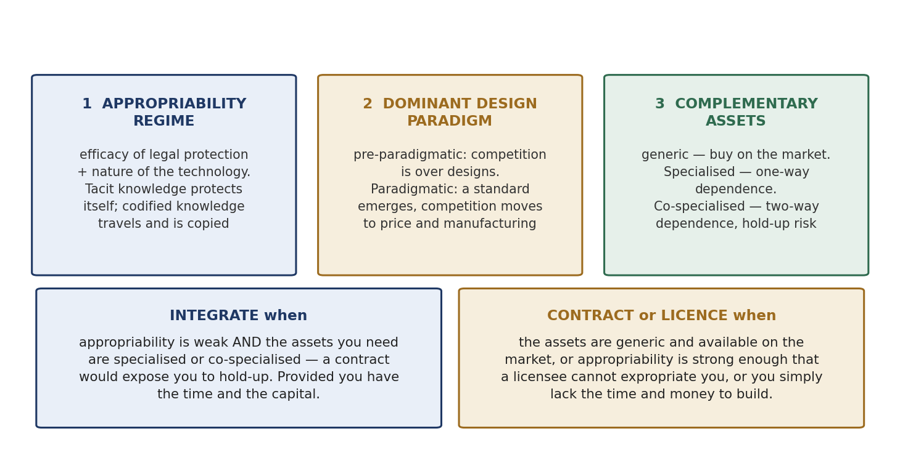
Figure 2.13 The three building blocks, and the integrate-or-contract decision.
- Appropriability regime. Can the innovator capture the returns? Two determinants: how effective legal protection is, and the nature of the technology. Tacit knowledge protects itself because it cannot easily be transferred. Codified knowledge travels and is copied.
- Dominant design paradigm. From Abernathy and Utterback. Before a standard emerges (pre-paradigmatic) competition is over designs. Once a dominant design appears (paradigmatic), competition shifts to price and manufacturing — and complementary assets become decisive.
- Complementary assets. Everything besides the invention needed to reach the customer: manufacturing, distribution, marketing, service, brand, approvals. Three types — generic (buy them on the market), specialised (one-way dependence), co-specialised (two-way dependence, which creates hold-up risk).
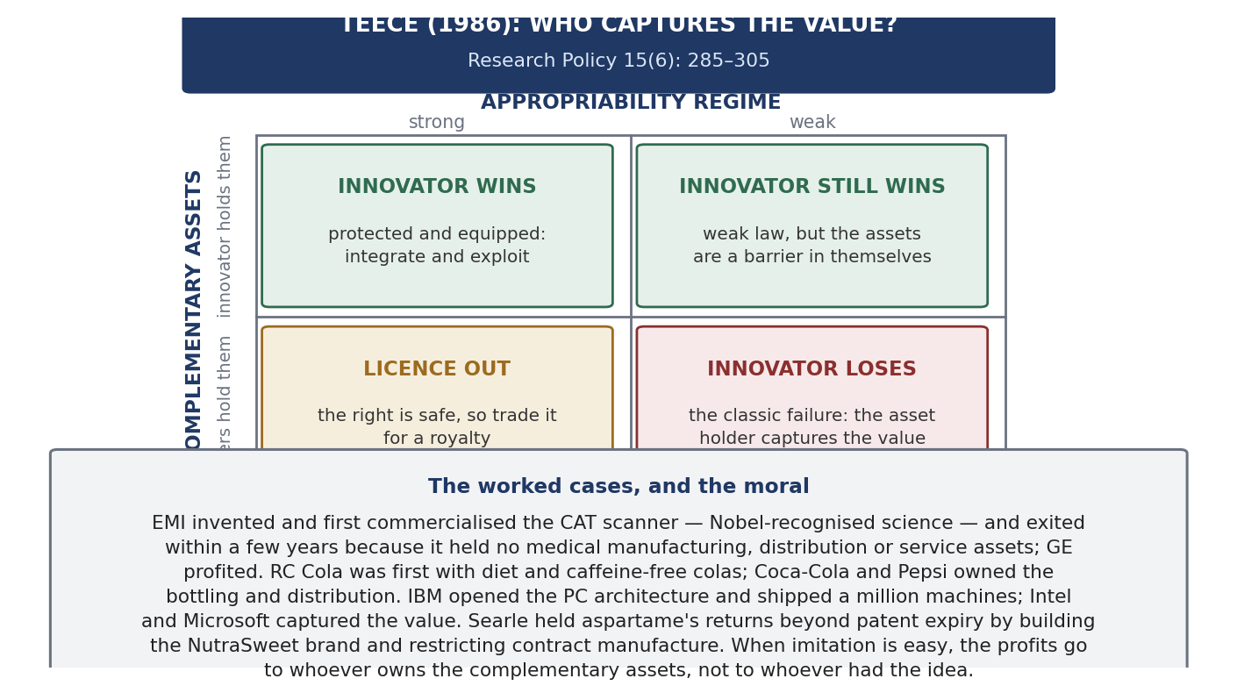
Figure 2.14 The framework as a grid, with the cases that populate it.
The decision rule. If appropriability is WEAK and the assets you need are specialised or co-specialised, a contract exposes you to hold-up, so INTEGRATE — build or buy the assets — provided you have time and money. If the assets are GENERIC, or appropriability is strong enough that a licensee cannot steal the technology, CONTRACT or LICENCE. If appropriability is weak and you have neither time nor assets, you lose, and the asset holder captures the value.
The cases, which you should name: EMI invented and first sold the CAT scanner — Nobel-recognised science — and left the business within a few years because it had no medical manufacturing, distribution or service; GE took the market. RC Cola was first with diet and caffeine-free colas, and Coca-Cola and Pepsi, who owned the bottling and distribution, took the value. IBM opened the PC architecture and sold a million machines; Intel and Microsoft captured the value. G.D. Searle did the opposite and succeeded, protecting aspartame's returns beyond patent expiry by building the NutraSweet brand, restricting contract manufacture and continuing research.
Implication | Teece's conclusion
Integration | Where appropriability is weak and assets are specialised, integrate instead of contracting. Large firms therefore profit more from innovation, because they already own the assets. “Manufacturing often matters”
Collaboration | The middle route when integration is too slow or costly. It must be structured against hold-up: exclusivity, field-of-use limits, improvement and grant-back terms, diligence obligations, termination rights
Licensing | Best when appropriability is strong, so the licensee cannot expropriate you, and when you lack the complementary assets. It destroys value when appropriability is weak, because the disclosure needed for the licence equips the licensee to become a competitor
Public policy | If returns flow to holders of complementary assets, then a country that lets its manufacturing and commercialisation capability weaken cannot profit from its own inventions, however good its research. It also affects antitrust, because integration and collaboration may be efficient responses rather than restraints
Table 2.11 Structure your answer on these four rows — they are literally the words in the syllabus title.
Teece updated the framework in 2018 (“Profiting from Innovation in the Digital Economy”, Research Policy), applying it to platforms, ecosystems and dynamic capabilities: the complementors are the complementary assets, so the 1986 variables matter more than ever.
The sentence to close with
Commercial success does not guarantee economic success. A firm can win the market and still fail to earn a return on what it spent. That is Teece's point, and it is why IP management exists as a subject: the right is necessary but never sufficient. What converts a right into a return is the position you hold relative to everything else the customer needs.

Unit 3 — IP Commercialization
Unit 1 said what IP is. Unit 2 said how an organisation owns and prices it. Unit 3 is the machinery that turns a protected right into money, freedom to operate, or bargaining power. It continues directly from the pipeline at Figure 2.2.

3.1 What IP Commercialization Means
Definition
IP commercialization is choosing and executing the route by which an IP right becomes value — revenue, market position, freedom to operate or bargaining power — and then defending that route. Protection is the means; commercialization is the point. A patent left in a drawer costs a fee every year and earns nothing.

Because an IP right is a right to EXCLUDE, value comes in only two ways. Either you use the exclusivity yourself, by selling something nobody else may copy. Or you sell permission to others, by licensing, cross-licensing or assignment. Every route below is one of those two.
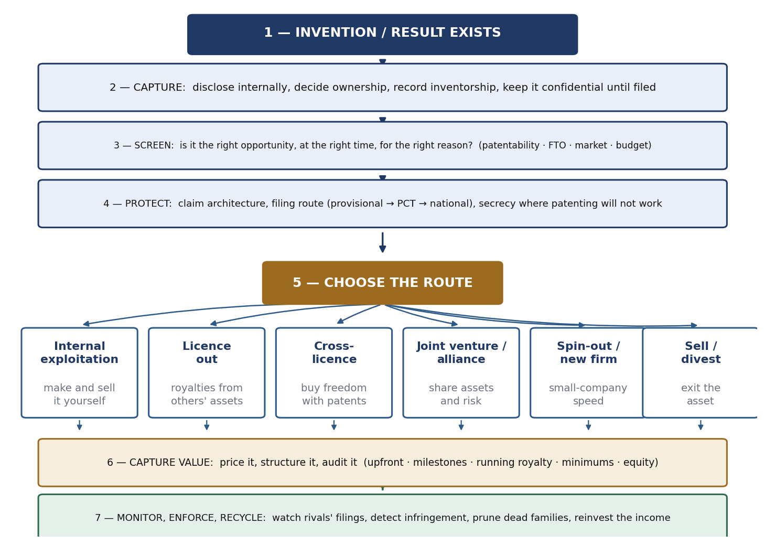
Figure 3.1 The seven steps, and the routes available at step five.

3.2 The Innovation Ecosystem: Where IP Sits
Commercialization is not a standalone activity. It is one loop inside a closed circulation of money and knowledge, whose goal is to create corporate wealth of two kinds at once — intellectual and financial.
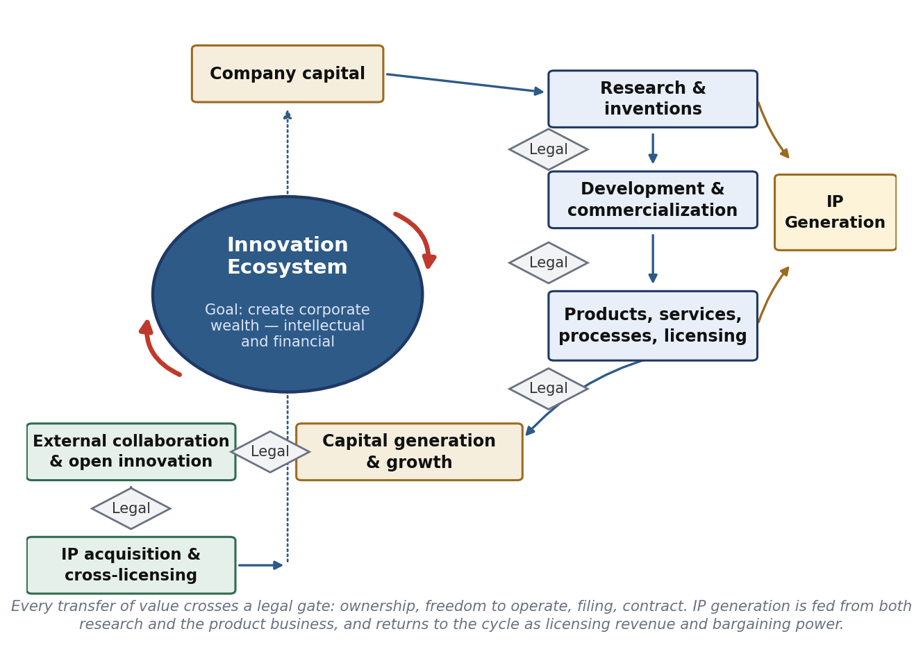
Figure 3.2 The corporate innovation ecosystem, with its legal gates.
Trace the loop. Company capital funds research and inventions. Research feeds development and commercialization, which produces products, services, processes and licensing. These generate capital and growth, which flows back into company capital and outward into open innovation and IP acquisition. Down the right side runs IP generation, fed both by research and by the product business, and it returns to the loop as licensing revenue and bargaining power.
The diamonds marked “Legal” are the lesson. Every transfer of value passes a legal gate: who owns it, are we free to operate, what is filed and when, what does the contract say. Where those gates are missing or late, value leaks — inventions that cannot be claimed because they were published first, collaborations where background and foreground IP were never separated, products found to infringe after the launch money is spent.

3.3 What a Company Needs to Commercialize Well
Seven requirements were set out in the guest session. Each is a failure mode when it is absent.
- Management commitment to innovation and IP creation. IP spend is easy to cut and the damage shows up years later, when there is nothing to licence and nothing to trade.
- Efficient and timely execution. In IP, timing is substantive. File after a conference presentation and the right may be void; file before the invention is properly described and it may be worthless.
- The right opportunity, at the right time, for the right reason. Three separate tests. The right reason matters because it decides how the claims are drafted and where you file.
- The right value proposition for the right market. One technology supports different propositions in different markets. Propositions are created, not discovered.
- Talented and motivated people. Steve Jobs's line: better to be a pirate than to join the navy. New technology needs people who work outside the process — but eventually the pirates must work with the navy, because the navy owns manufacturing and distribution.
- Open collaboration. No firm owns all the complementary assets it needs. IP is what makes collaboration safe: background and foreground IP defined in advance, field-of-use limits, publication rules.
- A symbiotic and synergistic relationship between IP legal and R&D. The one most often missing.
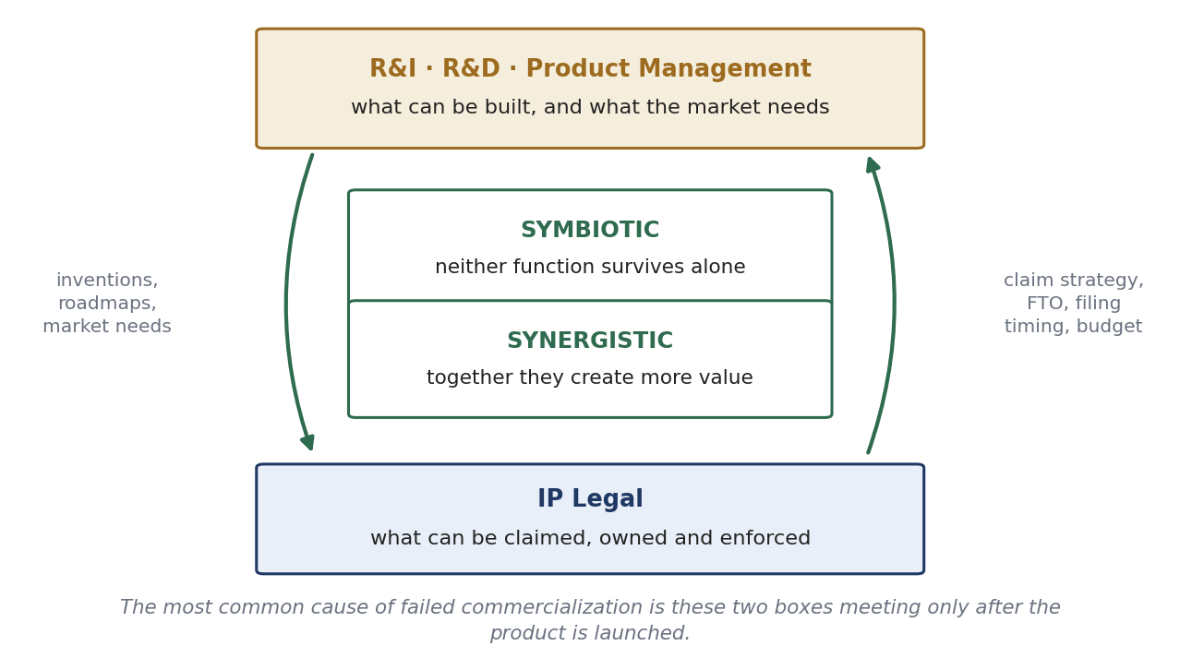
Figure 3.3 Symbiotic and synergistic.
Symbiotic means neither side can do its job alone: engineers cannot build a defensible asset without claim strategy, and lawyers cannot draft a valuable claim without knowing the technology and the roadmap. Synergistic means together they produce more. The engineer who understands claims designs inventions whose infringement can be detected; the attorney who knows the roadmap writes a core claim broad enough to cover products that do not exist yet.
Evidence: why the other requirements matter as much as the patent
A survey of 24 large Japanese corporations asked what actually limits their ability to profit from innovation (scale 0–4): access to the technology needed 2.62; difficulties in marketing 2.57; getting into production on time 2.48; inability to prevent copying 2.48; cost of capital 2.20; lack of suppliers 1.80.
Copying is NOT the biggest obstacle. A patent addresses one limitation out of six, and not the largest. That is the evidence for requirements 4, 6 and 7. It also points to the patent's second job, which does address the top-ranked limitation: getting access to technology you need, through cross-licensing.

3.4 What Motivates Inventors: USA and Germany Compared
Commercialization starts with an invention, and inventions come from people who must be motivated to make them and to report them. Two legal traditions create two different management problems.
 | United States | Germany and much of the EU
Who owns it | The company, usually by the employment contract | The inventor first, by statute; transferred when the employer claims it
What the employee must do | Disclose the invention and assign it | Report it; the employer must claim within four months or it is deemed claimed
What the inventor gets | A small honorarium, awards, recognition, career benefit | A legally enforceable share of commercial success, under government remuneration guidelines
What drives invention | Culture: an open environment that accepts failure as learning, which creates passion — and passion drives invention | Negotiated terms and process compliance. Culture, openness and passion are all challenges here
Practical effect | Low friction; the company must engineer motivation culturally | Higher administrative cost and a real royalty line — but a built-in financial incentive to invent and to disclose
Table 3.1 The full comparative position, including Japan and India, is at Table 2.9 in Unit 2.
The important thing to understand is that European companies DO end up owning inventions. Ownership is simply conditional, procedural and priced. That is why European IP departments run formal invention-disclosure systems as a legal necessity rather than good practice.

3.5 Portfolio Strategy: Build Around a Core Claim
The strategic question is not “should we patent this?” It is “what shape should the portfolio have?” The answer is a claim architecture.
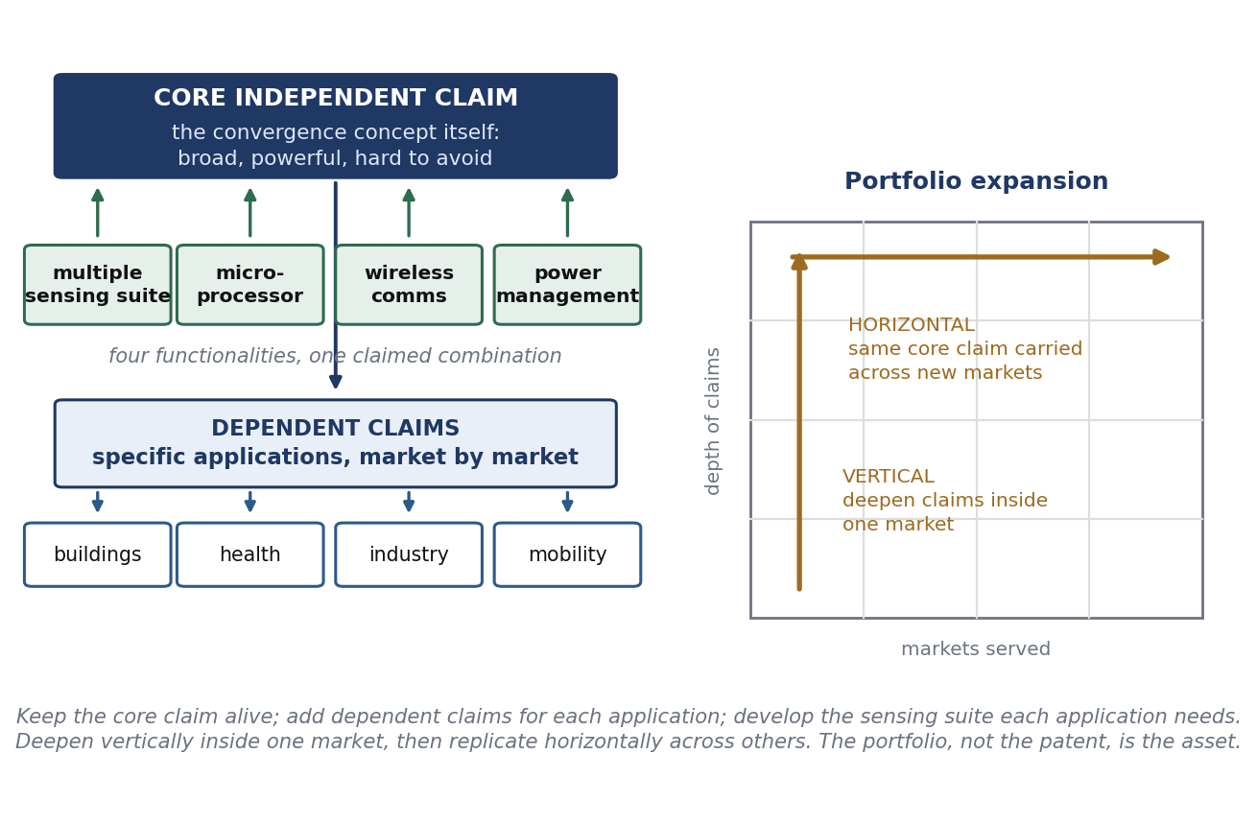
Figure 3.4 Core claim, dependent claims, and the two directions of growth.
- Core IP. One broad, powerful, independent claim on the overall concept. This is the asset that gets litigated, licensed and traded.
- Applications are dependent claims. Each specific use is claimed in dependence on the core.
- Applications vary by market, so the dependent layer is drafted market by market, not once.
- Expand it. Keep the core claim alive; add dependent claims for specific applications in specific markets; go VERTICAL by deepening inside one market (say, buildings); go HORIZONTAL by spreading across markets.
Why it works: vertical depth makes a competitor's entry into one market expensive, because they must avoid the core claim AND a dense layer of application claims. Horizontal spread multiplies the number of licensees who need the same core, raising both licensing value and cross-licensing power.
Evidence: why this architecture is necessary, not just tidy
The same survey asked what actually limits patents (0 = not true, 4 = very true). The top answer in every industry was: “competitors can legally circumvent patent rights or invent ways around them” — 2.58 out of 4. Next came cross-licensing (2.04) and rapid technological change (1.96); the lowest was compulsory licensing (1.00).
So the main weakness of a patent is invent-around. The response is to convert a single right, which can be circumvented, into a FIELD of rights, which cannot be circumvented economically. Two named strategies: BLANKETING, covering an area so densely that any route through it infringes something; and FENCING, filing around the core to block the substitute solutions a rival would otherwise use. This is exactly the architecture in Figure 3.4, reached from the opposite direction.

One note on the alternative. Where an invention cannot be seen in the finished product, secrecy is a real option, not a failure to file. But cheaper reverse engineering cuts both ways: it makes the innovator's secrecy easier to break, AND it makes infringement easier to detect, so patents become more enforceable. Both effects raise the propensity to patent. The exception is mechanical engineering, where process know-how still hides in the factory.

3.6 Cross-Licensing
Cross-licensing is how two firms that each block the other stop paying lawyers and start selling products.
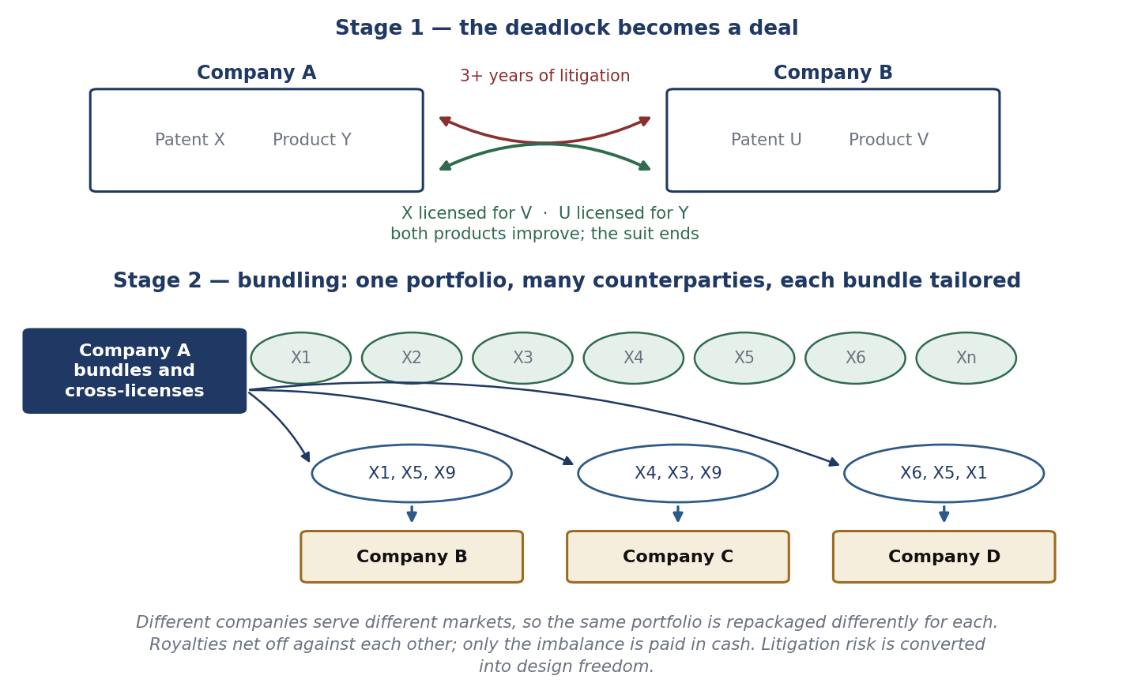
Figure 3.5 From litigation to cross-licence, and from single patents to bundles.
The use case. Company A obtains US Patent X. Company B sues A over its Product V position. Litigation runs more than three years. Later it emerges that X can improve V, and that B's Patent U can improve A's Product Y. So they cross-license: X for V, U for Y. Both products improve and the case ends. Nothing about the patents changed — only the realisation that each side valued the other's right more than the fight.
At portfolio scale, Company A bundles patents X1 to Xn and gives different bundles to different counterparties — X1, X5, X9 to B; X4, X3, X9 to C; X6, X5, X1 to D — because they serve different markets. Note that the same patent appears in several bundles: non-exclusive licensing lets one asset be sold many times.
Why cross-license instead of litigating
- Freedom to operate: in a multi-technology product somebody always holds a relevant right.
- Cost and time: three years of litigation produces no product.
- Royalty netting: payments offset and only the difference is paid in cash, so a strong portfolio lowers your net royalty bill.
- Design freedom: engineers optimise the product instead of the claim chart.
- Option value: a portfolio worth holding purely to trade — which is why defensive portfolios are rational.
CNY 1.38 trillion | 21.8% | 7,000+ | 165,000+
Huawei R&D over the last decade | R&D as a share of revenue in 2025 (CNY 192.3 billion) | Standards contributions in 2025 | Active patents at end-2025; over 260 licence agreements in twenty years
Table 3.2 Huawei: huge R&D input, a very large portfolio, heavy standards participation — the three preconditions for cross-licensing from strength.
The third column explains the other two. A firm that contributes thousands of proposals to technical standards will hold patents essential to those standards; a firm holding standard-essential patents can licence everyone who implements the standard; and a firm that also manufactures needs licences running both ways. Standards, patents and cross-licensing are one subject, not three. Standards bodies now require participants to disclose essential patents and commit to licensing on FRAND terms.

3.7 Licensing
Licensing is the commonest way to generate IP value and the hardest thing to negotiate. The reason is structural: the buyer wants to minimise the value, the seller wants to maximise it, and there is no market price to appeal to. Agreeing the valuation is therefore the gate through which every other term passes.
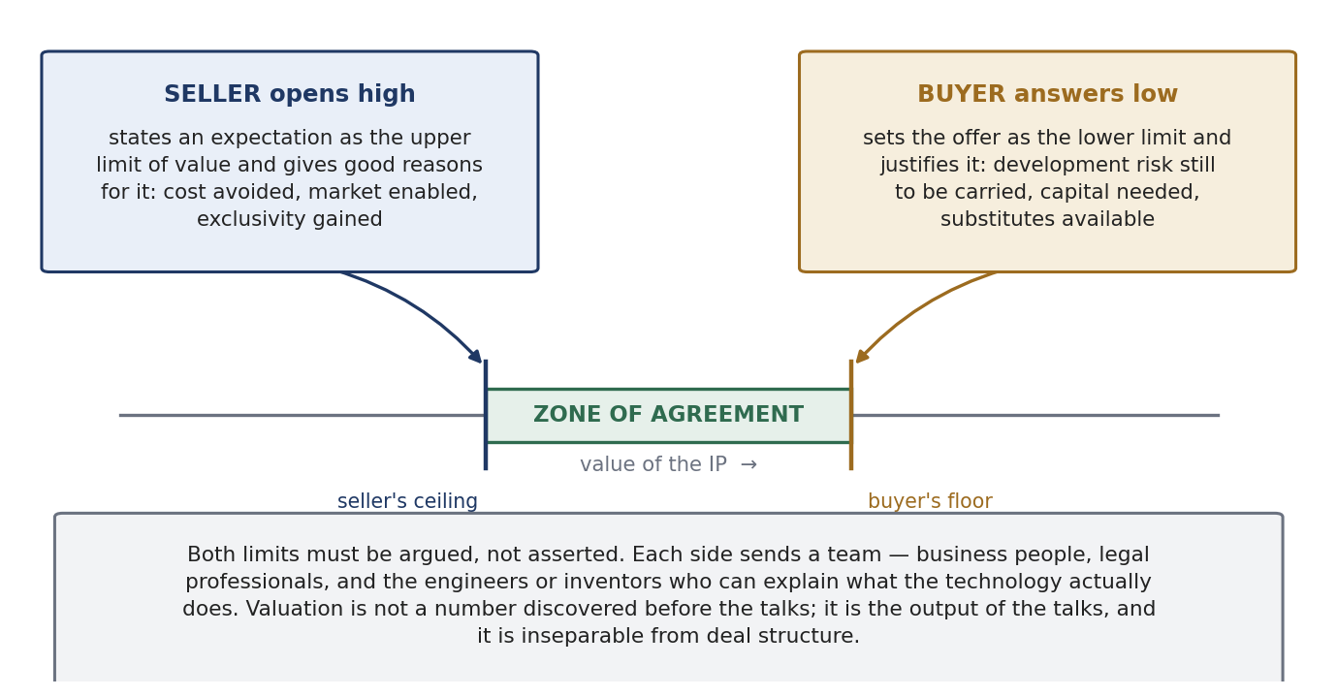
Figure 3.6 Two justified limits, then a zone of agreement.
The method that works is an exchange of JUSTIFIED limits. The seller states an expectation as the upper limit and gives good reasons. The buyer states an offer as the lower limit and gives clear justifications. What makes it work is not the numbers but the reasons — comparable deals, the cost of developing it independently, the size of the market it opens, the remaining risk, the substitutes available.
Both sides should send a TEAM: business experts, legal professionals, and engineers or inventors. Each is there for a reason. Business owns the commercial case and the budget. Legal owns risk, warranties and enforceability. The engineers are the only people who can say what the technology really does and what it would cost a competitor to work around it. A negotiation run only by lawyers produces a safe agreement with no upside; run only by business people it produces promises that cannot be kept.
On academic versus corporate licensing: in the USA the value assessment is similar in both worlds, but the process differs because of compliance, government regulation, federal funding conditions, export controls and conflict-of-interest rules. In the EU the academic and corporate worlds differ much more, because the inventor is a party with statutory rights, not merely an employee.
What is actually negotiated in a licence
Term | What it does | Where value moves
Grant and exclusivity | Exclusive, sole or non-exclusive | Exclusivity earns a premium but puts all the risk on one licensee's performance
Field of use and territory | Limits the licence to defined uses and countries | Lets the same IP be licensed many times without conflict
Financial structure | Upfront, milestones, running royalty, minimum annual royalty, equity | Upfronts price certainty; milestones share risk; minimums stop a licensee sitting on the right
Royalty base and rate | The figure the percentage applies to | The base matters as much as the rate — see 3.8
Diligence obligations | Milestones the licensee must actually meet | Protects the licensor against a licence used to shelve a rival technology
Reporting and audit | Statements, records, audit rights | Unauditable royalties are uncollectable royalties
Term and termination | Duration, breach, insolvency, reversion | Reversion is how a licensor gets a stalled technology back
Table 3.3 A licence is a bundle of decisions, not a price.

3.8 Setting the Number: the Royalty Thumb Rule
There is no magic formula and every situation is different. But where the IP is attached to a product, a rule of thumb can be used.
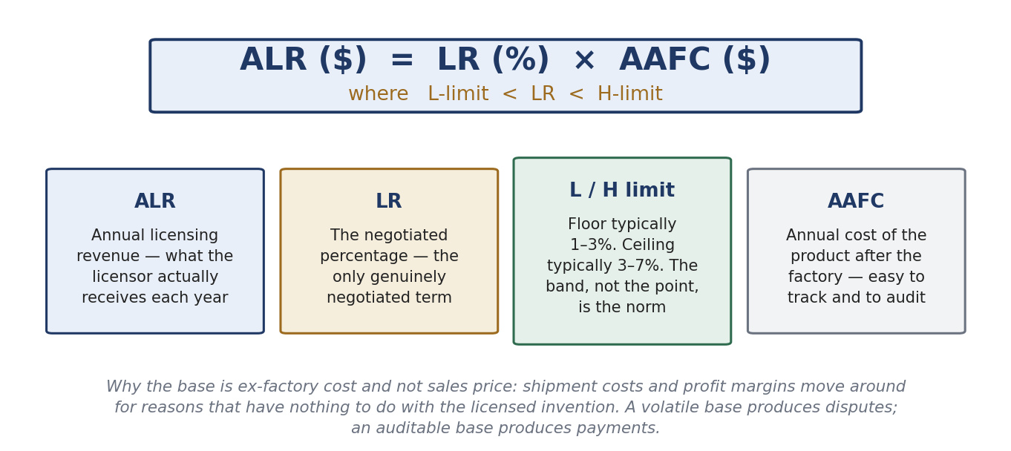
Figure 3.7 The thumb rule, term by term.
- ALR = annual licensing revenue, what the licensor actually receives each year.
- LR = the negotiated percentage. It is the only genuinely negotiated variable.
- The band. The lower limit of LR is typically 1 to 3; the upper limit is typically 3 to 7.
- AAFC = the annual cost of products AFTER the factory.
Why AAFC and not the sales price? Because AAFC is easy to track and to audit, and it deliberately excludes shipment cost and profit margin, which move for reasons that have nothing to do with the invention — fuel prices, discounting, channel mix, currency. A volatile base produces annual disputes. An auditable base produces payments.
Input | Conservative | Aggressive
Units per year | 400,000 | 400,000
Ex-factory cost per unit | USD 25 | USD 25
AAFC | USD 10,000,000 | USD 10,000,000
Negotiated LR | 1.5% | 6%
ALR | USD 150,000 | USD 600,000
Table 3.4 Same product, same base, four times the revenue — decided entirely by where LR lands in the band. That is why the justification exchange in 3.7 is worth doing properly.

3.9 Commercialization by Universities and Public Bodies

Bayh–Dole Act, 1980
Enacted as P.L. 96-517, codified at 35 U.S.C. §§200–212. It was Congress's answer to the poor commercialization record of federally funded technology.
- Title to inventions made with federal support goes to the contractor, where that contractor is a university, a nonprofit or a small business.
- A later presidential memorandum extended the same rule to all federal contractors, making it uniform.
- The contractor can therefore own a patent — which gives a private partner the exclusivity it needs to justify development investment.
- Before the Act there was no uniform policy and ownership generally stayed with the government.
The mechanism is worth stating plainly, because Bayh–Dole is often mistaken for a subsidy. It created no money. It created assignable exclusive rights, and therefore created a counterparty a company could negotiate with. Before 1980 a company asked to spend millions developing a technology that any competitor could equally licence had no reason to do so. The general lesson: exclusivity is less a reward for the inventor than a tool for attracting the downstream investment without which nothing reaches a customer.

The system in aggregate
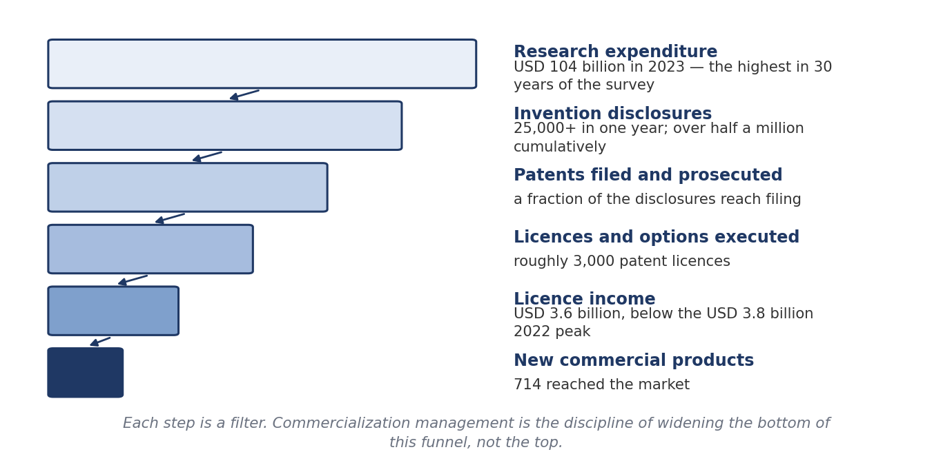
Figure 3.8 The academic commercialization funnel, 2023. Source: AUTM.
Two readings. Optimistic: USD 104 billion of research produced 714 new products and USD 3.6 billion of licence income in one year. Sober: USD 3.6 billion against USD 104 billion is about 3.5%, and income fell from the 2022 peak of USD 3.8 billion. Academic licensing is not a revenue strategy for a university. It is a public-mission strategy with a revenue by-product, and institutions that run it as a profit centre over-price early-stage licences and lose the deal.

Patent strategy: the filing sequence
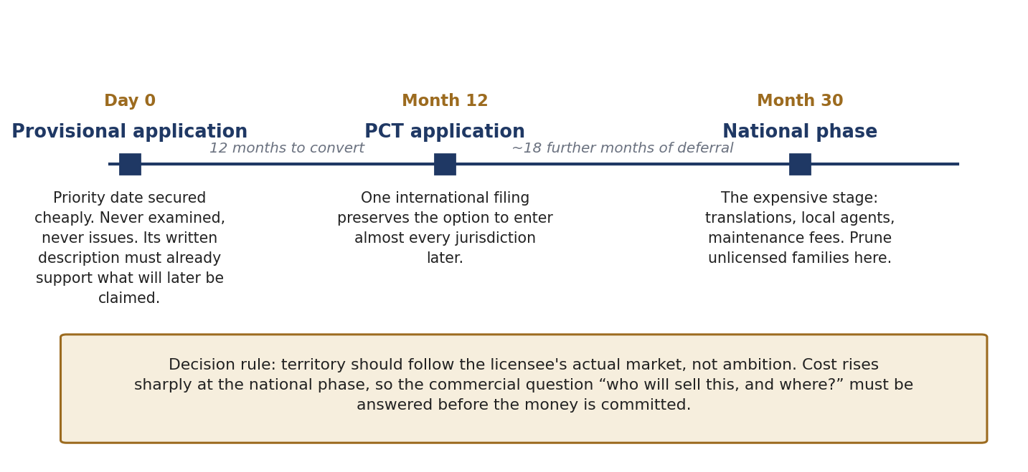
Figure 3.9 Provisional, PCT, national phase — a staged option on territory.
- Provisional. Fixes a priority date cheaply. Twelve months to convert. Never examined, never issues. Its written description must already support what you will later claim.
- PCT. One international filing keeps open the option of entering most countries, and defers the big cost decision by about eighteen months — time to find a licensee.
- National phase. The expensive stage: translations, local agents, annuities. Territory should follow the licensee's actual market. Unlicensed families are pruned here.
The sequence is a series of options, each bought for less than the sum it defers. The national phase is where money becomes irreversible, so that is where the commercial question must be answered: who will sell this, and where? Filing broadly to look impressive is the commonest and most expensive mistake in academic IP management.
The cautionary case: CRISPR-Cas9
In the CRISPR interference the Federal Circuit agreed that the University of California's earliest provisional lacked adequate written description. A priority date is only as good as the disclosure that supports it — a provisional drafted thinly to save money can forfeit the very date it was filed to secure.
For accuracy: the decision is Regents of the University of California v. Broad Institute (Fed. Cir., 12 May 2025). The court AFFIRMED the written-description holding, so UC gets priority only from its third provisional of January 2013. But it VACATED and remanded on conception, holding the Board wrongly conflated conception with reduction to practice. The priority dispute is therefore still unresolved. The lesson on provisionals stands.

Valuation heuristics
Method | What it is, and its limits
The 25% rule | Gives the licensor about a quarter of the licensee's expected operating profit on the product. Quick, communicable and a plausible opening number. Criticised for ignoring the IP's relative contribution — it treats a patent on one component of a thousand the same as one covering the whole. Use it as a SANITY CHECK on a negotiated rate, never as the derivation of one
Monte Carlo and scenario analysis | Replaces single-point forecasts with distributions over adoption, price and time to market. Well suited to staged technical and regulatory risk. The output is a range and a confidence level — honest, but harder to negotiate against. Only as good as the priors: precision is not accuracy
The three classical approaches | Cost (what it would take to recreate it — a floor); market (comparable transactions — persuasive where comparables exist); income (discounted cash flows — the only one that reflects exclusivity, remaining term and market size). Rules of thumb are shortcuts through the income approach
Table 3.5 Note: in Uniloc USA v. Microsoft, 632 F.3d 1292 (Fed. Cir. 2011), the 25% rule was held fundamentally flawed and evidence relying on it inadmissible. A heuristic is a negotiating aid, not a valuation.
The structural point — the most examinable idea here
Valuation of university IP is rarely the valuation of an asset in isolation. What is priced is a BUNDLE: the patent family, the inventor's continued involvement, the institution's willingness to take milestones instead of cash, and the licensee's cost of capital. Deal structure and valuation are the same conversation.
This is why a licensee will pay more in TOTAL for a structure weighted to milestones and royalties than a smaller sum upfront — the upfront comes from scarce cash at the licensee's highest cost of capital, while later payments come out of the revenue the technology itself generates. A licensing officer who understands this can raise the value of a deal while lowering its price.

The public research sector
The process is much the same. What differs is the objective, and therefore the terms. The stated priorities are: accelerated market penetration; priority to SMEs or promotion in underserved regions; capacity development; national security; global competitiveness; resilience of national infrastructure; preventing bad actors from obtaining the technology; and harmonious relations with the private sector.
These priorities explain deal terms that would look irrational in a company: non-exclusive licensing by default so many firms can deploy quickly; carve-outs and regional preferences for smaller domestic firms; local manufacturing obligations; march-in and government-use rights retained; security screening and export controls; and rates below what the market would bear, because the goal is diffusion, not income.
The comparison to remember
The corporation maximises appropriated value. The university maximises use, plus a share of the value. The public body maximises diffusion, subject to security. The same invention produces three different licences — which is why “what is this IP worth?” cannot be answered until you know who owns it and what they are trying to achieve.

Quick Revision

Ten Things to Remember
- IP is a subset of intangible property, never the reverse. Only IP has its own dedicated law; other intangibles rely on general law.
- Protection is the means; commercialization is the point. An unused patent is a liability with an annual fee.
- A patent is a right to exclude, not permission to work. Section 48, and the improved-chair example.
- The market prices quality, not count. The top 10% of a portfolio holds 80–85% of its value, so pruning creates value.
- Ideas are non-rival and only partly excludable, and IP supplies the excludability — which is how growth becomes endogenous (Romer, 1990).
- Non-proprietary does not mean unowned. Linux and Android are owned and openly licensed. Governance is a dial, not a switch.
- Everybody has human, structural and relational capital. Cognitive, conative and affective capital decide whether it converts.
- A policy is not enforceable by itself. It guides agreements; an agreement enforceable by law is a contract (s.2(h), s.10).
- The real weakness of a patent is invent-around, so build fields of rights: core claim, dependent claims, blanketing and fencing.
- Commercial success does not guarantee economic success. Teece: the returns go to whoever holds the complementary assets.

Key Numbers
Item | Figure | What it proves
Paris Convention; Bayh–Dole and Chakrabarty; CAFC; TRIPS; UDRP; India's IPR Policy | 1883; 1980; 1982; 1994; 1999; 2016 | The dates that built the system and triggered IP management
Stanford – Google | USD 336 million, 2005 | 1.8 million shares taken instead of a royalty
Cohen–Boyer | 468 licensees; USD 255 m to 2001; ~USD 35 bn product sales | A platform licensed widely, not closed to one firm
MIT, FY2025 | USD 60.9 m licence revenue; ~53% of portfolio licensed | The 53% is the real measure of culture
IIT Kharagpur | ~450 filed, 120 granted, 7 licensed | Good filing, narrow commercialisation neck
Academic aggregate, 2023 | USD 104 bn research; 25,000+ disclosures; USD 3.6 bn income; 714 products | Licence income is only about 3.5% of research spend
Intangibles, S&P 500 | 17% (1975) → 68% (1995) → 90% (2020) | Why IP became a board-level subject
Extra citation per patent | +3% market value; 20+ citations ≈ 54% premium | Hall, Jaffe & Trajtenberg: quality, not count
IP-intensive industries, USA | 41% of GDP; 44% of employment (2019) | Corrected version of the “27%” claim (27.7% on 2010 data)
Global patent filings | 3.5 m (2023) → 3.7 m (2024) | WIPO; +4.9%, fastest growth since 2018
Qualcomm licensing | ~USD 5.3 bn, ~68% pre-tax margin, FY2023 | The paradigm shift in one line item
Royalty band | LR floor 1–3%, ceiling 3–7%, applied to AAFC | The thumb rule
The 25% rule | 25% of licensee operating profit | Sanity check only; inadmissible after Uniloc (2011)
Patents for commercializing products | Japan 3.3 / Sweden 1.9 / USA 2.0 | Patents rank first in Japan, near-last in the West
Top limitation of patents | 2.58 of 4 | Competitors can legally invent around them
Huawei | 165,000+ patents; 260+ licence agreements | Cross-licensing from strength
German university inventors | 30% of gross licensing income | §42 ArbnErfG — gross, not net. IIT Bombay and Delhi: 70:30 of net
UDRP success rate | About 80–85% | Remedies are transfer or cancellation only — never damages

Corrections to Common Class Claims
Commonly said | The correct version
“27% of US jobs are IP-related.” | 27.7% on 2010 data (USPTO, 2012), rising to 44% of employment and 41% of GDP on 2019 data (USPTO, 2022). Quote the movement
“Only 10% of patents have value.” | Value is concentrated, not absent: the top 10% holds 80–85% of portfolio value (Scherer & Harhoff, 2000)
“Japan pioneered IP management.” | Japanese firms built strong patent cultures during catch-up, but the pro-patent era as a policy change was US-initiated, 1980–1982
“IP management began in 1990 / 1998.” | Say “the 1980s and 1990s”. No single year is defensible
“Intangibles are 92% of S&P 500 value.” | Ocean Tomo's own later estimate. Cite 90% for 2020 as the safe benchmark

Authorities to Cite
- Statutes: Patents Act 1970 — s.2(1)(j), s.2(1)(ja), s.2(1)(l), s.48. Indian Contract Act 1872 — s.2(h), s.10. Bayh–Dole Act 1980. ArbnErfG §42 (Germany). Patent Act Art. 35 (Japan). ACPA 1999. UDRP paras 4(a), 4(b), 4(c); INDRP. IAS 38 / Ind AS 38.
- Cases: Diamond v. Chakrabarty, 447 U.S. 303 (1980). Yahoo! Inc. v. Akash Arora, 1999 PTC (19) 201 (Del). Satyam Infoway v. Sifynet Solutions, (2004) 6 SCC 145. Uniloc USA v. Microsoft, 632 F.3d 1292 (Fed. Cir. 2011). Regents of the University of California v. Broad Institute (Fed. Cir., 2025).
- Prescribed reading: Bosworth & Webster (2006). Granstrand (2000), Towards Intellectual Capitalism. Anderson, Technology Transfer and Licensing.
- Primary scholarship: Teece (1986), Research Policy 15(6): 285–305. Romer (1990), JPE 98(5). Kuhn (1962). Arrow (1962). Kitch (1977). Heller & Eisenberg (1998). Chesbrough (2003). von Hippel (2005). Hall, Jaffe & Trajtenberg (2005). Edvinsson & Malone (1997). Sullivan (1998). Scherer & Harhoff (2000). Mendelow (1991). OECD (1996).

Likely Questions
Short answer
- Distinguish IP management from IP strategy and IP administration.
- Why is a patent called a negative right?
- Distinguish invention, innovation and “new invention” under the Patents Act.
- What are the four pillars of a knowledge economy, and where does IP law sit?
- State the two properties of ideas on which endogenous growth theory rests.
- Distinguish a policy, an agreement and a contract.
- What is AAFC, and why is it used instead of the sales price?
- State the UDRP three-pronged test and say how the INDRP differs.
Long answer
- Explain the relationship between intangible assets, intellectual capital, IP and IPR, and why most intellectual capital never appears on a balance sheet.
- How would you measure the IP culture and IP value of an organisation?
- Discuss the paradigm shift from “intellectual property” to “intellectual capital”.
- How is IP transformed into intellectual capital in a competing economy? Apply the analysis to India.
- Do ideas and IPR determine economic growth? Give both sides.
- Can technology create value without exclusive ownership? Use examples and mechanisms.
- Draft or critique an IP policy, and contrast a corporation, a university and a research organisation.
- What happens when trademark and domain name rights collide? Apply it to a domain registered in good faith before the trademark arose.
- Explain Teece's framework and its four implications.
- Explain how a company commercializes IP, from invention to revenue.
End of document.

